A Project Report On

**Unified Payment Interface Fraud Detection Using Feed**

**Forward Neural Network**

Submitted in partial fulfillment of the requirements for the award of the degree of **BACHELOR OF TECHNOLOGY**

### In

**COMPUTER SCIENCE AND ENGINEERING**

By

Channaganu Vineela (21NN1A05D7)

Vuyyuru Eshitha Reddy (21NN1A05J3)

Potlacheruvu Thulasi (21NN1A05G9)

Sesham Risitha (21NN1A05H4)

Under the Esteemed Guidance of

Dr.V. Sujatha

Professor

### DEPARTMENT OF COMPUTER SCIENCE AND ENGINEERING

**VIGNAN’S NIRULA INSTITUTE OF TECHNOLOGY AND SCIENCE FOR WOMEN**

**PEDAPALAKALURU, GUNTUR-522005**

**(Approved by AICTE, NEW DELHI and Affiliated to JNTUK, Kakinada.)**

**2021-2025**

**VIGNAN’S NIRULA INSTITUTE OF TECHNOLOGY & SCIENCE FOR WOMEN**

**PEDAPALAKALURU ROAD, GUNTUR-522005**

**(Approved by AICTE &Affiliated to JNTUK, Kakinada)**

**DEPARTMENT OF COMPUTER SCIENCE AND ENGINEERING**



CERTIFICATE

This is to certify that this project report entitled “**Unified Payment Interface Fraud Detection Using Feed Forward Neural Network** ” is a bonafide record of work carried out by **Channaganu Vineela (21NN1A05D7), Vuyyuru Eshitha Reddy (21NN1A05J3), Potlacheruvu Thulasi (2INN1A05G9), Sesham Rishita (21NN1A05H4)** under the guidance and supervision of Dr. V. Sujatha in partial fulfillment of the requirements for the award of the degree of **Bachelor of Technology** in **Computer Science and Engineering** in **VIGNAN’S NIRULA INSTITUTE OF TECHNOLOGY & SCIENCE FOR WOMEN, GUNTUR.**

**Project Guide Head of the Department**

**Dr. V. Sujatha Dr. V. Lakshman Narayana Professor Professor**

**EXTERNAL EXAMINER**

**DECLARATION**

We hereby declare that the work described in this project work, entitled “**Unified Payment Interface Fraud Detection Using Feed Forward Neural Network**” which is submitted by us in partial fulfilment for the award of **Bachelor of Technology** in the Department of **Computer Science and Engineering** to the **Vignan’s Nirula Institute of Technology and Science for Women**, affiliated to Jawaharlal Nehru Technological University Kakinada, Andhra Pradesh, is the result of work done by us under the guidance of **Dr.V. Sujatha**, Professor.

The work is original and has not been submitted for any Degree/ Diploma of this or any other university.

### Place: Guntur Date:

### PROJECT ASSOCIATES

Channaganu Vineela (2INN1A05D7)

Vuyyuru Eshitha Reddy (21NN1A05J3)

Potlacheruvu Thulasi (21NN1A05G9)

Sesham Rishita (21NN1A05H4)

**ACKNOWLEDGEMENT**

We express our heartfelt gratitude to our beloved principal **Dr. P. Radhika** for giving a chance to study in our esteemed institution and providing us all the required resources.

We would like to thank **Dr. V. Lakshman Narayana**, **Professor, Head of the Department of Computer Science and Engineering**, for his extended and continuous support, valuable guidance and timely advice in the completion of this project thesis.

We wish to express a profound sense of sincere gratitude to our Project Guide **Dr.V. Sujatha, Professor, Department of Computer Science and Engineering**, without whose help, guidance and motivation this project thesis could not have been completed successfully.

We also thank all the faculty of the Department of Computer Science and Engineering for their help and guidance of numerous occasions, which has given us the cogency to build-up adamant aspiration over the completion of our project thesis.

Finally, we thank one and all who directly or indirectly helped us to complete our project thesis successfully.

### PROJECT ASSOCIATES

Channaganu Vineela (2INN1A05D7)

Vuyyuru Eshitha Reddy (21NN1A05J3)

Potlacheruvu Thulasi (21NN1A05G9)

Sesham Rishita (21NN1A05H4)

Unified Payment Interface Fraud Detection

Using

Feed Forward Neural Network

**ABSTRACT**

Unified Payment Interface (UPI) systems have revolutionized digital transactions in India, but they are increasingly targeted by fraudulent activities that pose significant financial risks. The “UPI Payment Fraud Detection using Feedforward Neural Network (FNN)” is a deep learning-based solution developed to efficiently and accurately detect fraudulent UPI transactions in real time. Existing models such as Convolutional Neural Networks (CNN), Long Short-Term Memory (LSTM), and Gated Recurrent Units (GRU) have been applied in fraud detection; however, they often face challenges in effectively capturing key transactional patterns and can result in misclassifications under complex behavioural scenarios. The proposed model, FNN, enhances detection accuracy by focusing on critical transactional parameters such as transaction amount, time, location, device type, and transaction frequency, thereby improving fraud classification performance. Implemented using the Stream lit framework, the system offers an interactive interface where users can input transaction details and receive instant fraud probability predictions. The model classifies transactions as either Legitimate or Fraudulent, achieving an impressive accuracy of 92%.This system eliminates reliance on manual transaction reviews, reduces human error, and enables timely intervention. Key advantages include high accuracy, real-time detection, and automation, making it a valuable tool for both users and financial institutions. By leveraging deep learning techniques and behavioural analysis, the model helps in minimizing financial losses, enhancing payment security, and increasing user trust, thereby contributing to a safer and more reliable digital payment ecosystem.

**TABLE OF CONTENTS**

|  |  |
| --- | --- |
| **Chapter No Name of the Chapter** | **Page No** |
| **Chapter 1 Introduction** | 1 |
| 1.1 Introduction | 1 |
| 1.2 Understanding the Significance of Variables | 2 |
| 1.3 Fraud Patterns in the Dataset | 2 |
| 1.4 Role of Deep Learning | 3 |
| 1.5 Challenges in UPI Payment Fraud Detection | 4 |
| 1.6 Benefits of using a UPI Payment Fraud Detection System | 5 |
| **Chapter 2 Literature Survey**  2.1 Literature Review  2.2 Gaps identified from the Literature Review | 7  7  14 |
| **Chapter 3 System Analysis** | 15 |
| 3.1 System Analysis | 15 |
| 3.2 Existing System | 15 |
| 3.3 Proposed System | 17 |
| 3.4 Feasibility Study | 19 |
| **Chapter 4 Requirements Specifications** | 21 |
| 4.1 Purpose, Scope, Definition | 21 |
| 4.1.1 Purpose | 21 |
| 4.1.2 Scope | 21 |
| 4.1.3 Definition | 21 |
| 4.2 Requirement Analysis | 21 |
| 4.2.1 Functional Requirements | 22 |
| 4.2.2 User Requirements Analysis | 22 |
| 4.2.3 Non-Functional Requirements | 22 |
| 4.3 System Requirements | 23 |
| 4.3.1 Software Requirements | 23 |
| 4.3.2 Hardware Requirements | 23 |
| **Chapter 5 System Design** | 24 |
| 5.1 System Architecture | 24 |
| 5.2 Modules | 25 |
| 5.2.1 Feedforward Neural Network (FNN) Model for Fraud Detection | 25 |

|  |  |
| --- | --- |
| 5.2.2 Streamlit Framework for User Interface | 28 |
| 5.3 Design Overview | 30 |
| 5.4 UML Diagrams | 31 |
| 5.4.1 Use case Diagram | 32 |
| 5.4.2 Activity Diagram | 33 |
| 5.4.3 Sequence Diagram | 34 |
| 5.4.4 Component Diagram | 34 |
| 5.4.5 Deployment Diagram | 35 |
| 5.3 Algorithm | 35 |
| **Chapter 6 Implementation** | 38 |
| 6.1 Steps for Implementation | 38 |
| 6.2 Coding | 44 |
| **Chapter 7 Testing** | 51 |
| 7.1 Testing | 51 |
| 7.2 Types Of Tests | 52 |
| 7.2.1 Unit Testing | 52 |
| 7.2.2 Integration Testing | 53 |
| 7.2.3 Functional Testing | 53 |
| 7.2.4 System Testing | 54 |
| 7.2.5 White Box Testing | 54 |
| 7.2.6 Black Box Testing | 54 |
| 7.3 Test Cases | 55 |
| **Chapter 8 Results And ScreenShots** | 56 |
| **Chapter 9 Conclusion And FutureWork** | 73 |
| 9.1 Conclusion And FutureWork | 73 |
| **Chapter 10 Bibliography** | 74 |
|  |  |

**LIST OF FIGURES**

|  |  |  |  |
| --- | --- | --- | --- |
| **S.No** | **Fig No** | **Description of figure** | **Page No** |
| 1 | 1.1 | UPI Fraud Monitoring | 1 |
| 2 | 1.2 | UPI Transaction Analysis | 3 |
| 3 | 1.3 | Demographics Indicating Fraudulent  Patterns | 4 |
| 4 | 1.4 | UPI Fraud Detection System | 5 |
| 5 | 5.1 | System Architecture | 28 |
| 6 | 5.3 | Types and categories of UML diagram | 30 |
| 7 | 5.4.1 | Use Case Diagram | 32 |
| 8 | 5.4.2 | Activity Diagram | 33 |
| 9 | 5.4.3 | Sequence Diagram | 34 |
| 10 | 5.4.4 | Component Diagram | 35 |
| 11 | 5.4.5 | Deployment Diagram | 35 |
| 12  13 | 8.1.1  8.1.2 | Home Page  About Us Page | 56  58 |
| 14 | 8.2.1 | Sign Up Page | 57 |
| 15 | 8.2.2 | Login Page | 57 |
| 16 | 8.3.1 | Test Page Result 1 | 59 |
| 17 | 8.3.2 | Test Page Result 2 | 59 |
| 18 | 8.4.1 | Result Page 1 | 60 |
| 19 | 8.4.2 | Result Page 2 | 60 |
| 20 | 8.5.1 | History Page | 61 |
| 21 | 8.6.1 | Accuracy and loss | 62 |
| 22 | 8.6.2 | F1-Score, Recall, Precision | 63 |
| 23 | 8.6.3 | Confusion Matrix | 65 |
| 24 | 8.6.4 | ROC curves | 67 |
| 25 | 8.6.5 | Performance Patterns | 69 |
|  |  |  |  |
|  |  |  |  |

**LIST OF TABLES**

|  |  |  |  |
| --- | --- | --- | --- |
| **S.No** | **Table No** | **Table Description** | **Page No** |
| 1 | 2.1 | Literature Survey | 9 |
| 2 | 8.6.5 | Tenfold cross validation | 71 |

**LIST OF ACRONYMS**

|  |  |
| --- | --- |
| **Acronyms** | **Definition** |
| AL | Artificial Intelligence |
| ML | Machine Learning |
| DL | Deep Learning |
| CNN | Convolutional Neural Network |
| LSTM | Long Short-Term Memory |
| FNN | Feed Forward Neural Network |
| UML | Unified Modeling Language |
| ROC | Receiver Operating Characteristic |
| TP | True Positive |
| FP | False Positive |
| AUC | Area Under Curve |

**CHAPTER 1**

**INTRODUCTION**

## CHAPTER 1 INTRODUCTION

### Introduction

For a nation, economic stability and security are closely tied to the integrity of its financial systems. Digital transactions, particularly through UPI (Unified Payments Interface), have revolutionized the financial landscape, enabling seamless and instant money transfers. However, with the rapid adoption of UPI, the risk of fraudulent activities has also surged, posing a significant challenge to financial institutions and users. Detecting and preventing fraudulent transactions is crucial to maintaining trust in digital payment systems.

UPI fraud detection is essential for financial security. While research has enhanced fraud detection methods, real-time prediction using historical transaction data remains limited. The dynamic nature of fraudulent tactics further complicates accurate detection.



### Fig 1.1 UPI Fraud Monitoring

Transaction-based parameters such as transaction amount, frequency, and location influence fraud detection. Input parameters for fraud detection vary across different financial institutions, making it challenging to collect and analyze data comprehensively.  
Recent advancements in technology have enabled the development of sophisticated models for fraud detection, leveraging multiple variables such as transaction history, user behavior, and anomaly detection techniques. This project aims to provide insights into one such predictive model, focusing on key factors like transaction patterns, device usage, geolocation, and spending behavior.

### Understanding the Significance of Variables

Transaction frequency, location consistency, and device integrity are fundamental factors in assessing UPI payment fraud. These indicators play a crucial role in detecting fraudulent activities such as unauthorized transactions, identity theft, and financial scams. Understanding their patterns is essential for strengthening fraud detection mechanisms and ensuring secure digital transactions. Fraudulent transactions often exhibit unusual frequency or irregular payment amounts. Monitoring user behavior helps detect anomalies, such as sudden spikes in transactions or inconsistent spending patterns, which may indicate fraudulent activity.

Optimizing detection models ensures accurate classification of legitimate and suspicious transactions. Users typically make transactions from specific locations and devices. Significant deviations, such as payments from geographically distant regions within short time intervals or frequent device changes, can signal account compromise or unauthorized access. Real-time tracking and adaptive authentication methods enhance fraud prevention.

Just as rainfall distribution impacts agricultural productivity, transaction flow patterns influence fraud detection accuracy. Unusual fund transfers, rapid money movement across multiple accounts, or repeated small payments to unverified merchants may indicate fraud or money laundering attempts. Analysing these patterns with machine learning helps mitigate risks.

### Fraud Patterns in the Dataset

The dataset presents a comprehensive landscape of UPI payment fraud patterns, encompassing a wide range of fraudulent activities that threaten financial security and economic stability. From transaction-level anomalies like unauthorized payments, phishing scams, and identity theft to behavioral fraud indicators such as unusual transaction frequency, irregular payment locations, and device inconsistencies, the dataset captures the evolving tactics used by fraudsters.

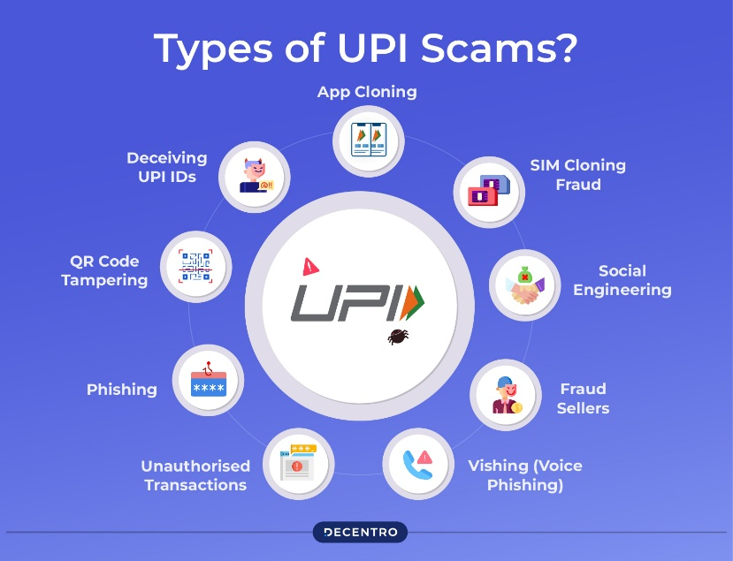Furthermore, it includes fraudulent schemes like fake merchant transactions, money laundering attempts, and social engineering attacks, highlighting the need for robust fraud detection mechanisms.

### Fig 1.2 UPI scams

An e-FIR can be filed online by visiting the official website of the police department concerned and submitting the necessary details. A few police departments have also launched their official mobile application, which can be used to file an e-FIR. The process is user-friendly and ensures quick registration of complaints without the need to visit a police station. Users can track the status of their FIR and receive updates through SMS or email notifications.

### Role of Deep Learning

Predictive modeling in UPI payment fraud detection hinges on the utilization of deep learning algorithms, offering unparalleled insights from vast transactional datasets. Feature extraction and anomaly detection techniques are paramount, enabling the identification of fraudulent transactions based on behavioral patterns and transaction attributes. The fraud detection system using deep learning is an intelligent security solution that analyzes UPI transaction data to detect anomalies based on features like transaction amount, frequency, time intervals, device information, and geolocation. This system employs a Feedforward Neural Network (FNN) to process transaction data, learning complex patterns to distinguish between genuine and fraudulent transactions.

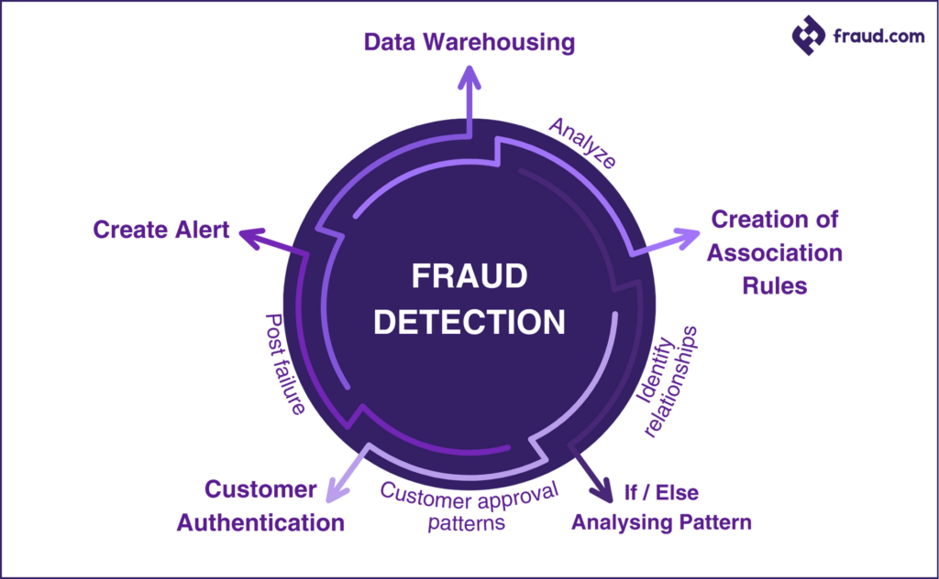In addition to this, implemented with the Streamlit framework, in which the system and its provides a user-friendly interface through HTML pages. Users input specific transaction details, which are then utilized by the deep learning model to classify transactions as legitimate or fraudulent. The seamless integration of Streamlit facilitates efficient data processing and user interaction, ensuring a smooth user experience.

### Fig1.3 Demographic Indicator Various Properties of fraud detection

* 1. **Challenges in UPI Payment Fraud Detection**

The exponential growth of digital transactions presents a formidable challenge to UPI payment security, placing immense pressure on fraud detection systems to identify and prevent fraudulent activities in real time. As transaction volumes surge and fraudsters adopt increasingly sophisticated tactics, the need for advanced fraud detection techniques becomes evident. Deep learning models, such as Feedforward Neural Networks (FNNs), offer a data-driven approach to analyzing transaction patterns and detecting anomalies. By leveraging features such as transaction frequency, amount, device information, and behavioral patterns, these models enhance fraud detection accuracy while minimizing false positives. In the face of evolving fraud strategies, the integration of deep learning-based fraud detection is essential to ensuring the security and efficiency of UPI transactions while mitigating financial risks and enhancing user trust. Moreover, the scalability of deep learning models ensures that they can handle the growing volume of UPI transactions without compromising performance.

### Benefits of using a UPI Payment Fraud Detection System

**Enhanced Transaction Security:** The system ensures real-time fraud detection by monitoring transaction patterns and identifying anomalies, reducing financial risks and enhancing trust in digital payments. Deep learning models make it harder for fraudsters to exploit security loopholes, ensuring compliance with financial regulations.

### Fig 1.4 UPI Recommendation

**Resource efficiency:** In UPI payments focus on optimizing computational power, network bandwidth, and infrastructure to ensure secure, fast, and cost-effective transactions. By leveraging lightweight encryption, AI-driven fraud detection, and efficient API calls, UPI minimizes processing delays and server load, enhancing scalability. Optimized authentication methods, such as biometric verification and tokenization, reduce redundant security checks while maintaining high protection levels.

**Risk Mitigation**: Early fraud detection prevents unauthorized transactions, minimizing financial losses and protecting users from scams, phishing, and identity theft. By analyzing transaction frequency, device characteristics, and location anomalies, the system reduces fraud risks and ensures secure payments.

**Time Savings**: Automated fraud detection speeds up identifying and blocking suspicious transactions, reducing the burden on fraud analysts. Real-time alerts and verification prevent fraudulent activities before they escalate, ensuring seamless user transactions.

**Access to Expertise**: Even small businesses and non-tech users benefit from AI-powered fraud detection, ensuring secure transactions without requiring cybersecurity expertise. This enhances financial inclusion and safeguards users from evolving threats.

**Data-driven decision-making**: Adaptive learning mechanisms improve fraud detection over time, refining detection models through historical and real-time data analysis. This minimizes false positives and negatives, ensuring efficient, secure, and disruption-free transactions.

Overall, a UPI Payment Fraud Detection System strengthens transaction security, optimizes fraud prevention, and builds trust in digital payments through AI-driven, real-time detection and adaptive learning.

**CHAPTER 2**

**LITERATURE SURVEY**

## CHAPTER 2 LITERATURE SURVEY

## Literature Review

M. Chen et al. [2023] introduced a multi-channel Convolutional Neural Network (CNN) to analyze UPI transaction patterns. Their model utilized transaction embeddings and time-series data, achieving an accuracy of 98.01% with an AUC of 0.9981. By leveraging Gradient-weighted Class Activation Mapping (Grad-CAM), they improved fraud interpretability, reducing data processing costs by 50% while maintaining high detection performance. However, the model incurs high computational costs and relies on large, labeled datasets, making it less practical for real-time detection in resource-constrained environments.

Vikram Taneja et al. [2023] proposed a contextual fraud detection framework that integrates Natural Language Processing (NLP) and deep learning to examine transaction descriptions for signs of fraud. The system effectively identifies fraud linked to social engineering and deceptive text patterns, offering context-aware insights. Nevertheless, the approach is limited to text-based inputs and lacks effectiveness in handling numerical or algorithmic fraud types like card cloning.

W. Wang et al. [2023] proposed a GAN-based anomaly detection model for financial fraud detection. The generator created synthetic fraudulent transactions, while the discriminator learned to distinguish real from fraudulent ones. The model effectively detected unseen fraud patterns, outperforming conventional supervised learning methods with a fraud detection accuracy of 96.45%. Still, GANs require meticulous hyperparameter tuning and are susceptible to issues like mode collapse and overfitting, especially with smaller datasets.

X. Zhang et al. [2023] utilized Graph Neural Networks (GNNs) to model financial transactions as graphs. Their architecture used attention-based pooling and sparsity constraints to identify suspicious transaction flows. This approach improved fraud detection rates by analyzing hidden relationships between accounts, providing better insights into money laundering activities. However, GNNs are computationally intensive and may not adapt efficiently to dynamic transaction graphs with evolving fraud patterns.

S. M. Abdullah et al. [2023] proposed an Autoencoder-based deep learning model for UPI fraud detection. Their model used unsupervised learning to reconstruct legitimate transactions and flag deviations as potential fraud. By combining autoencoders with transfer learning, they achieved over 95% accuracy, reducing reliance on labeled fraud datasets. Despite its strengths, the model struggles to generalize across all types of fraud and lacks the speed required for real-time fraud prevention.

Siddharth Rao et al. [2023] introduced a federated learning-based fraud detection approach that allows multiple financial institutions to collaboratively train a model without sharing raw transaction data. This ensures privacy and enhances fraud detection through shared learning. However, decentralized training introduces complexities in optimization and communication efficiency, which can slow down model convergence.

R. Soundararajan et al. [2022] developed an Optimal Fraud Prevention System (OFPS) based on LSTM networks. Their model integrated real-time biometric authentication and transaction heuristics to detect anomalies. By processing transaction sequences and behavior patterns, LSTM achieved robust fraud detection, reducing false positives in real-world financial datasets. Nonetheless, the high memory consumption and computational complexity of LSTM models make them less scalable for large-scale deployments.

F. Setiawan et al. [2022] proposed a Transformer-based approach for fraud detection in online payments. Transformers captured long-range dependencies between transactions, identifying hidden fraud patterns in financial transactions. Their model achieved state-of-the-art performance in fraud classification tasks. However, the model demands significant computational resources and is prone to overfitting when trained on limited data.

Y.-P. Huang et al. [2020] explored deep reinforcement learning (DRL) for real-time fraud detection in financial transactions. Their DRL-based fraud prevention system adapted to new fraud patterns, outperforming rule-based fraud detection systems. The model continuously updated itself based on fraudulent transaction behavior. However, DRL requires complex training processes and fine-tuning of the reward function, making deployment challenging.

N. Yang et al. [2020] introduced a hybrid model combining CNN, LSTM, and an attention mechanism for detecting financial fraud. The CNN captured transaction embeddings, while LSTM handled sequential dependencies. Attention mechanisms improved interpretability by highlighting critical features contributing to fraudulent activity. Their model demonstrated superior accuracy compared to standalone deep learning methods.

|  |  |  |  |  |
| --- | --- | --- | --- | --- |
| **S. No** | **Title & Year of Publication** | **Work Description** | **Advantages** | **Disadvantages** |
| **1** | **Multi-Channel CNN for UPI Fraud Detection (M. Chen et al., 2023)** | This study applied a multi-channel Convolutional Neural Network (CNN) for detecting fraud in Unified Payments Interface (UPI) transactions. It used transaction embeddings and time-series data to improve classification accuracy. The model also integrated Gradient-weighted Class Activation Mapping (Grad-CAM) to enhance interpretability. | The model achieved high accuracy of 98.01% with an AUC score of 0.9981, demonstrating superior performance in fraud detection. It reduced the cost of data processing by 50%, making it more efficient for large-scale financial datasets. The inclusion of Grad-CAM allowed better interpretability of the model’s decisions. | The computational cost of training and deploying the model is high, making it less feasible for real-time fraud detection in resource-limited environments. The model also requires a large labeled dataset for effective learning, which can be challenging to obtain in fraud detection scenarios. |
| 2 | **Contextual Fraud Detection using NLP and Deep Learning (Vikram Taneja et al., 2023)** | This research combined Natural Language Processing (NLP) and deep learning to analyze transaction descriptions for fraud detection. The model extracted linguistic patterns indicative of fraudulent activity. | The model is effective in detecting frauds that involve social engineering scams and deceptive transaction descriptions. It supports context-aware fraud detection by incorporating linguistic analysis into the fraud detection process. | The approach is limited to text-based fraud detection and does not work well for numerical transaction data. It is less effective in detecting purely algorithmic fraud, such as card cloning or automated bot transactions. |
| **3** | **GAN-Based Anomaly Detection for Financial Fraud (W. Wang et al., 2023)** | This study introduced Generative Adversarial Networks (GANs) to generate synthetic fraudulent transactions, allowing the model to learn hidden fraud patterns. The discriminator was trained to classify real and fake transactions. | GAN-based approaches improve the detection of unseen fraud patterns by learning the underlying transaction distribution. The method achieved 96.45% accuracy in fraud detection, demonstrating its effectiveness. The approach also generalizes better to emerge fraud trends compared to traditional classify models. | The training of GAN models requires careful tuning of hyperparameters, which can be challenging. GANs are prone to mode collapse, where the generator fails to produce diverse fraudulent transactions, leading to biased learning. Overfitting is also a concern when training on small datasets. |
| **4** | **Graph Neural Networks (GNNs) for Transaction Fraud (X. Zhang et al., 2023)** | This study modeled financial transactions as graphs and used Graph Neural Networks (GNNs) with attention-based pooling to identify fraudulent patterns. Sparsity constraints were applied to enhance detection accuracy. | The use of GNNs allows for the identification of hidden relationships between accounts involved in fraudulent transactions. The model significantly improves detection rates, especially for complex financial frauds such as money laundering. It is highly effective in analyzing transaction networks. | The computational requirements for GNNs are high, making them less suitable for real-time fraud detection. The model struggles to adapt to highly dynamic transaction graphs, where new fraudulent patterns frequently emerge. |
| **5** | **Autoencoder-Based UPI Fraud Detection (S. M. Abdullah et al., 2023)** | This research utilized autoencoders, an unsupervised deep learning approach, to reconstruct normal transactions and flag deviations as potential fraud. Transfer learning was applied to enhance fraud detection performance. | Autoencoder-based models are effective in detecting anomalies without requiring labeled fraud data, reducing dependency on labeled datasets. The model achieved 95% accuracy, proving its reliability. It also enhances fraud detection in cases where fraudulent transactions are not well-defined. | The effectiveness of autoencoders varies across different types of fraudulent activities, limiting their generalizability. Additionally, the model lacks real-time processing capability, making it unsuitable for immediate fraud prevention. |
| 6 | **Federated Learning-Based Fraud Detection (Siddharth Rao et al., 2023)** | This study introduced a federated learning approach for fraud detection, allowing multiple financial institutions to collaboratively train a fraud detection model while maintaining data privacy. | Federated learning enhances fraud detection through collaborative learning across financial organizations. It ensures user confidentiality by keeping sensitive transaction data decentralized. The approach improves fraud detection without requiring data sharing between | The decentralized nature of federated learning makes training efficiency a major challenge. The model requires specialized optimization techniques to manage distributed learning, which can be complex. |
| 7 | **Optimal Fraud Prevention System (OFPS) using LSTM (R. Soundararajan et al., 2022)** | This work proposed a Long Short-Term Memory (LSTM)-based model that integrates biometric authentication and transaction heuristics for fraud detection. The system monitors transaction sequences to identify anomalies in real-time. | The model effectively reduces false positive rates and ensures accurate fraud detection in real-world financial datasets. It adapts well to evolving fraud patterns, making it a robust solution for online transaction monitoring. | The high memory usage of LSTM models makes them inefficient for large-scale deployment. Additionally, the model’s complexity increases significantly when applied to real-time fraud detection, leading to increased computational overhead. |
| **8** | **Transformer-Based Fraud Detection for Online Payments (F. Setiawan et al., 2022)** | This work applied transformer models to detect fraudulent transactions by capturing long-range dependencies between different transactions. The model was designed to identify hidden fraud patterns in financial networks. | Transformer models achieve state-of-the-art fraud detection performance by efficiently analyzing large datasets. They are effective in detecting complex fraud behaviors that traditional models might miss. | Transformer models require high computational power, making them expensive to deploy. Additionally, they are prone to overfitting when trained on small datasets, which reduces their generalization ability. |
| 9 | **Deep Reinforcement Learning (DRL) for Real-Time Fraud Detection (Y.-P. Huang et al., 2020)** | This research developed a Deep Reinforcement Learning (DRL)-based fraud prevention system that dynamically adapts to new fraud patterns using reward-based learning. | The model continuously updates its fraud detection strategies based on transaction behavior, making it more adaptable than traditional rule-based systems. It improves fraud detection accuracy over time by learning from new fraud trends. | DRL models are complex to train and require significant computational resources. The performance of the model heavily depends on the proper tuning of the reward function, which can be challenging. |
| 10 | **Hybrid CNN-LSTM with Attention Mechanism for Financial Fraud (N. Yang et al., 2020)** | This study combined CNN for transaction feature extraction and LSTM for analyzing sequential transaction patterns. An attention mechanism was incorporated to focus on important features. | The hybrid architecture improves interpretability by identifying critical transaction features associated with fraud. It also enhances fraud detection accuracy compared to standalone CNN or LSTM models. The model effectively captures both spatial and temporal transaction dependencies. | The computational complexity of the hybrid model is high due to the combination of CNN, LSTM, and attention mechanisms. Large training datasets are required to optimize performance, which can be challenging in real-world scenarios. |

**Table 2.1. Literature Survey**

**2.2 Gaps identified from the Literature Review**

The following are the research gaps identified from the literature review encompassing the work of ten different authors.

* UPI fraud detection faces challenges due to the high computational resources required for real-time analysis, especially in low-resource environments like rural areas or on low-end mobile devices.
* Real-time fraud identification is difficult to achieve when detection systems have high response times, allowing fraudulent transactions to go unnoticed until it's too late.
* Limited and imbalanced UPI transaction data makes it challenging to build accurate detection systems, often resulting in poor performance on unseen fraud cases.
* Fraud detection systems often fail to recognize subtle behavioural differences between genuine and fraudulent transactions.

**CHAPTER 3**

**SYSTEM ANALYSIS**

## CHAPTER 3 SYSTEM ANALYSIS

### System Analysis

The UPI Payment Fraud Detection System is a web-based application designed to identify and mitigate fraudulent transactions in real time. By leveraging machine learning techniques, the system analyses inputs such as transaction amount, frequency, transaction history, device ID, IP address, and user behaviour to detect potential fraud. Implemented within the Streamlit framework, the application provides an intuitive interface where users and financial institutions can monitor and validate suspicious transactions. Behind the scenes, a pre-trained machine learning model processes transaction data and predicts whether a transaction is legitimate or fraudulent. The system's primary objective is to enhance the security of UPI-based transactions, reducing financial losses due to fraudulent activities. By harnessing data-driven insights, the UPI Payment Fraud Detection System aims to improve the reliability and security of digital payments, fostering trust in online financial transactions.

**Problem definition**

The problem addressed by the UPI Payment Fraud Detection System is the increasing prevalence of fraudulent activities in digital transactions. Traditional fraud detection methods rely on rule-based approaches and manual reviews, which are often slow and ineffective against sophisticated fraud schemes.

With the rapid growth of UPI transactions and evolving fraud techniques, there is a pressing need for an intelligent, data-driven fraud detection approach. The system bridges this gap by providing real-time fraud detection based on transaction attributes, user behaviour, and anomaly detection techniques. By addressing these challenges, the UPI Payment Fraud Detection System aims to safeguard users from financial fraud, ensuring a secure and seamless digital payment experience.

### Existing System

### The existing system relies on Convolutional Neural Networks (CNN) and other traditional machine learning models such as Logistic Regression, Random Forest, and Support Vector Machines (SVM) for fraud detection. The CNN model, designed to recognize intricate transaction patterns, achieves an accuracy of approximately 83%. Long Short-Term Memory (LSTM) and Gated Recurrent Unit (GRU) models achieve accuracies of 75% and 79%, respectively. While machine learning models Logistic Regression and SVM models achieve accuracies of 89% and 90%, while Random Forest performs slightly better with an accuracy of 91%.

While these models offer reasonable accuracy, they have several limitations. CNN models are computationally intensive and require extensive training data to generalize effectively. LSTM and GRU models, despite their efficiency in sequential data processing, struggle with high-dimensional transaction datasets, making them less effective in capturing complex fraud patterns. Random Forest, although capable of handling non-linearity, may not always distinguish subtle fraudulent behaviours, leading to occasional false positives and negatives.

Moreover, these models lack real-time adaptability, making them less effective in detecting evolving fraud patterns. As fraudsters continuously refine their techniques, the need for a more adaptive and scalable approach becomes evident.

### Disadvantages of Existing System

### Addressing these disadvantages is essential for improving fraud detection processes and enhancing financial security and trust in online transactions. The development of intelligent systems like AI-powered Fraud Detection Systems can help overcome these challenges by providing organizations with real-time, data-driven insights tailored to specific fraud patterns and evolving threats. These systems leverage machine learning models to analyze user behavior, detect anomalies, and prevent fraudulent activities, ensuring a more secure and reliable digital ecosystem

### Limited Accuracy:

Despite achieving 80% accuracy with Convolutional Neural Network and 75% with Long short-term memory, the existing models fall short of providing foolproof fraud detection. Their inability to detect sophisticated fraud techniques results in occasional misclassifications, which can either falsely flag legitimate transactions or fail to detect fraud. This limitation arises due to the dynamic nature of fraudulent activities, where fraudsters continuously evolve their methods to bypass traditional detection systems. Additionally, reliance on historical data makes these models.

### Inability to Capture Complex Relationships:

### Machine learning models such as Logistic Regression and SVM struggle with high-dimensional data, limiting their ability to detect intricate fraud schemes. Their reliance on predefined feature sets restricts their adaptability to new and emerging fraud patterns. Additionally, these models often assume linear or simple decision boundaries, making them less effective in capturing complex, non-linear fraud behaviors.

### Limited Scalability:

### The existing system's reliance on logistic regression and support vector classifier algorithms may pose scalability challenges, particularly when dealing with large datasets or real-time data streams. This limitation can hinder the system's efficiency and responsiveness, especially as the volume of UPI Fra data continues to grow.

### Potential Overfitting:

### Both logistic regression and support vector classifier algorithms are susceptible to overfitting, especially when trained on limited or unrepresentative datasets. Overfitting can result in reduced generalization performance and inaccurate predictions on unseen data, undermining the reliability of the system's recommendations.

### Limited Adaptability:

### The existing fraud detection algorithms may lack the adaptability required to accommodate diverse transaction behaviors, evolving fraud tactics, and dynamic financial ecosystems. This limitation can lead to suboptimal fraud detection, especially in scenarios where fraudsters continuously modify their strategies to evade detection.

**Lack of Transparency:**

The black-box nature of logistic regression and support vector classifier algorithms may lead to a lack of transparency in the decision-making process. Stakeholders may find it challenging to understand the rationale behind the generated by reducing trust and confidence in the system.

### Proposed System

In the proposed model, a Feedforward Neural Network (FNN) is employed to enhance the accuracy and reliability of UPI fraud detection. This advanced deep learning approach achieves an impressive accuracy rate of nearly 92%, marking a significant improvement over the existing system's Long short-term memory and Gated recurrent unit which achieve accuracy of 75% and 79%, respectively.

The Feedforward Neural Network (FNN) excels in capturing complex, non-linear relationships within transaction data, leveraging its multi-layer architecture to identify intricate fraud patterns and anomalies that traditional models may overlook. By processing transactional features through multiple hidden layers with activation functions, the model effectively distinguishes fraudulent transactions from legitimate ones, even in highly dynamic financial environments.

Furthermore, FNN’s ability to learn from vast amounts of historical and real-time transaction data enhances its adaptability to evolving fraud tactics. Unlike rule-based systems and conventional machine learning models that rely on predefined feature sets, FNN dynamically extracts relevant patterns, improving detection accuracy and reducing false positives.

By leveraging deep learning techniques, the proposed FNN-based fraud detection system ensures more precise and reliable identification of fraudulent transactions. This not only strengthens financial security but also minimizes disruptions for legitimate users. Additionally, the scalability and robustness of FNN contribute to fostering trust and confidence in digital payment systems, enabling a proactive and intelligent approach to combating UPI fraud.

### Advantages of Proposed System

The proposed UPI Fraud Detection System offers a powerful tool for financial institutions and users to enhance transaction security, leading to safer and more reliable digital payment experiences.

**Enhanced Accuracy:**

The proposed model, utilizing a Feedforward Neural Network (FNN), achieves an impressive accuracy rate of nearly 92%, surpassing the accuracies of existing logistic regression and support vector classifier algorithms. This higher accuracy ensures more precise and reliable fraud detection, enhancing transaction security and reducing financial risks in UPI payment systems.

### Ability to Capture Complex Relationships:

The Feedforward Neural Network (FNN) excels in capturing intricate relationships within transaction data, leveraging its multi-layer architecture to identify complex fraud patterns and anomalies. This capability enables the model to provide more precise and adaptive fraud detection, ensuring enhanced security in UPI payment systems.

**Robust and Adaptive Framework:**

The Feedforward Neural Network (FNN) enhances fraud detection by leveraging learned feature representations to identify fraudulent transactions based on their similarity to known fraud patterns. This approach provides a robust and adaptive framework for handling diverse transaction behaviors, ensuring accurate and timely fraud detection across various financial ecosystems.

### Interpretability and Transparency:

The Feedforward Neural Network (FNN) enhances fraud detection with its ability to learn complex transaction patterns while maintaining interpretability through techniques such as feature importance analysis and attention mechanisms. This transparency fosters trust and confidence in the system, empowering users and financial institutions to make informed decisions in preventing UPI fraud.

### Improved Scalability:

The proposed model's Feedforward Neural Network (FNN) is designed to handle large datasets and real-time transaction streams efficiently. This scalability ensures the system's responsiveness to dynamic financial environments and evolving fraud tactics, accommodating the growing volume of digital payment data while maintaining high accuracy in fraud detection.

### Reduced Risk of Overfitting:

By leveraging a combination of advanced machine learning techniques and optimization strategies, the proposed model mitigates the risk of overfitting. This ensures better generalization performance on unseen data and minimizes the likelihood of the model learning from noise in the training data, resulting in more reliable and robust crop recommendations.

### Feasibility Study

The main objective of the feasibility study is to test the technical, Operational and Economic feasibility for adding new modules and debugging old proposed system. and debugging the old proposed system, ensuring improved system performance and reliability. It also aims to assess resource availability and identify potential risks in implementation.  
This evaluation helps determine whether the updated system will meet user needs effectively and efficiently.

We have:

* Technical Feasibility
* Operational Feasibility
* Economic Feasibility

### Technical Feasibility:

Technical feasibility evaluates the system's capacity to be developed and deployed using available technologies and resources. With widely accessible web development frameworks like Streamlit and machine learning libraries such as scikit-learn, the necessary technical infrastructure is readily attainable. Additionally, the scalability of cloud computing platforms enables efficient deployment and management of computational resources, ensuring the system's technical viability.

### Operational Feasibility:

### Operational feasibility examines the system's ability to integrate seamlessly into users' existing financial workflows and transaction processes. The user-friendly interface and intuitive design of the web application ensure ease of use, minimizing the need for extensive training or technical support. Furthermore, the system's capability to provide real-time fraud detection and alerts based on transactional patterns enhances its practical utility and adoption potential among financial institutions and digital payment users, ensuring a secure and efficient UPI transaction environment.

### Economic Feasibility:

Economic feasibility evaluates the cost-effectiveness of developing and maintaining the UPI fraud detection system relative to its anticipated benefits. While initial development costs may include expenses related to software development, data acquisition, and infrastructure setup, the potential long-term benefits in terms of enhanced fraud prevention and financial security justify these investments. Moreover, the system's scalability allows for cost-effective expansion and adaptation to meet the needs of diverse financial institutions and digital payment ecosystems, ensuring robust protection against evolving fraud tactics.

**CHAPTER 4**

**REQUIREMENTS SPECIFICATIONS**

## CHAPTER 4

## REQUIREMENTS SPECIFICATIONS

### Purpose, Scope, Definition

* + 1. **Purpose**

The purpose of the software requirements Specification is the basis for the entire project. It lays the foundation and also framework that every team involved in the development will follow. It is used to provide critical information to multiple teams like development, quality assurance, operations, and maintenance. Software requirements specification is a rigorous assessment of requirements before the more specific system designs and its goal is to reduce later the redesign. It should also provide a realistic basis for estimating product costs, risks, and also schedules.

### Scope

The scope is the part of project planning that involves determining and documenting a list of specific project goals, deliveries, features, functions, tasks, deadlines, and ultimately costs. In other words ,it is what needs to be achieved and the work that must be done to deliver a project .The Software scope is well defined boundary which encompasses all the activities that are done to develop and deliver the software product. The software scope clearly defines the all functionalities and artifacts to be delivered as a part of the software.

### Definition

The Software Requirement Specification is a description of a software system to be developed. It is modeled after a software system to be developed. It is modeled after business requirements specification, also known as the stakeholder requirements specification.

### Requirement Analysis

The process to gather the software requirements from clients, analyze and document them is known as requirements engineering or requirements analysis. The goal of engineering requirement is to develop and maintain sophisticatedand descriptive System/Software Requirements Specification documents. It serves as the foundation for system design, development, testing, and maintenance throughout the software lifecycle.

It is a four-step process generally, which

* Feasibility Study
* Requirements Gathering
* Software Requirements Specification
* Software Requirements Validation

The basic requirements of our project are:

* Research Papers
* Camera

### Functional Requirement Analysis

Functional requirements explain what has to be done by identifying the necessary task, action, or activity that must be accomplished. Functional requirements analysis will be used as the top–level functions for functional analysis.

### User Requirements Analysis

User Requirements Analysis is the process of determining user expectations for a new or modified product. These features must be

Quantifiable, relevant, and detailed.

### Nonfunctional Requirement Analysis

Non-functional requirements describe the general characteristics of a system.They are also known as quality attributes. Some typical non-functional requirements are Performance, Response Time, Throughput, Utilization, and Scalability.

### Performance:

The performance of a device is essentially estimated in terms of efficiency, effectiveness, and speed.

* Short response time for a given piece of work.
* High throughput (rate of processing work)
* Short data transmission time.
* Low power consumption to enhance energy efficiency.

### Response Time:

Response is the time a system or functional unit takes to react to a given input

### System Requirements

By meeting these software and hardware requirements, developers can effectively develop, test, and deploy the UPI fraud detection System, ensuring compatibility, performance, and scalability across different developments environments. Additionally, adherence to these requirements ensures efficient utilization of resources and facilitates seamless integration of the system into farmers' workflows for improved crop selection processes.

### Software Requirements

* + - * **Operating System** – Windows 10 or 11 Ultimate, Linux, Mac.
      * **Visual Studio Code**: Utilized as the Integrated Development Environment (IDE) for writing and editing code, facilitating collaborative development, and managing project files.
      * **Google Colab:** Used for data preprocessing, model training, and testing machine learning algorithms in a cloud-based Jupyter notebook environment, leveraging Google's computational resources.
      * **Packages**: numpy, pandas, sci-kit-learn
      * **Python Anywhere:** Employed for hosting the web application developed using the Streamlit framework, providing a platform for deploying and managing the system online.

### Hardware Requirements

* + - * **Processor i3/i5:** The system can be developed and run on a standard PC equipped with an Intel Core i3 or i5 processor, ensuring sufficient processing power for development tasks and system operation.
      * **RAM - 4GB:** A minimum of 4GB RAM is recommended to support multitasking and handle computational tasks efficiently during the development and deployment phases.
      * **Hard Disk Drive -** Minimum 500 GB: Adequate storage space is required to store project files, datasets, and software installations. A minimum of 500 GB hard disk drive ensures ample storage capacity for the system's requirements.

**CHAPTER 5**

**SYSTEM DESIGN**

## CHAPTER 5 SYSTEM DESIGN

### System Architecture

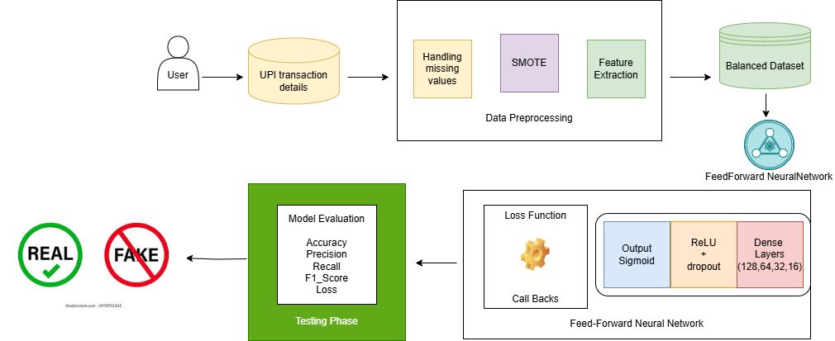Identify and select a suitable dataset for UPI payment fraud detection. Perform data pre-processing and split the preprocessed data into training and testing sets. Choose an algorithm (Fully Connected Neural Network - FNN) for fraud detection based on its suitability for identifying fraudulent transactions. Train and test the FNN model, then generate the model. Using that model, create a web application using Stream lit, where users can input transaction details and receive fraud detection results as output.

### Fig-5.1. System Architecture

### The process begins with the user providing UPI transaction details, including transaction amount, frequency, device ID, IP address, and past transaction history. The data then undergoes preprocessing, which involves handling missing values to ensure data completeness, applying SMOTE (Synthetic Minority Over-sampling Technique) to balance the dataset by generating synthetic samples for underrepresented fraudulent transactions, and performing feature extraction to identify key transaction attributes relevant for fraud detection. Once preprocessing is completed, a balanced dataset is created to prevent model bias towards non-fraudulent transactions. This dataset is then fed into the FNN model, which consists of multiple dense layers (128, 64, 32, and 16 neurons) responsible for learning transaction patterns. The model employs the ReLU activation function along with dropout to prevent overfitting, while the output layer uses a sigmoid activation function to classify transactions as either fraudulent or legitimate. During training, the model optimizes its predictions using a loss function and callbacks to improve efficiency. After training, the model undergoes evaluation using testing data, where key performance metrics such as accuracy, precision, recall, F1-score, and loss are analyzed to assess its effectiveness. Finally, based on the learned patterns, the model classifies transactions as either real (legitimate) or fake (fraudulent), allowing users and financial institutions to detect and mitigate fraudulent activities in digital payments effectively

* 1. **Modules**

There are 2 modules used. They are:

1. Fully Connected Neural Network (FNN) as the Deep Learning Model
2. Streamlit Framework for User Interface
   * 1. **Fully Connected Neural Network (FNN) as the Deep Learning Model**

Component diagrams are used to display various components of a software system as well as subsystems of a single system. They are used to represent physical things or components of a system. It generally visualizes the structure and organization of a system. They also show the dependencies and relationships between different components. By understanding these interactions, developers can ensure modularity and reduce system complexity. Component diagrams also help in identifying reusable components and assist in system maintenance. Here’s a simplified explanation of how it works along with some formulas:

### ****FNN Architecture Used in UPI Fraud Detection Model:****

1. **Input Layer:** Takes multiple transaction features such as amount, time, frequency, device type, and location.
2. **Hidden Layers:** Multiple fully connected layers apply activation functions to capture complex fraud patterns.

**Formula for Linear Transformation:**

**Z=W⋅X+B**

# **A=f(Z)**

# Where:

# W weight matrix,

* X is the input feature vector,
* B is the bias term,
* Z=W⋅X+BZ is the linear transformation,
* A=f(Z) is the activation output with f(Z) as the activation function (e.g., ReLU)

1. **ReLU Activation Function:** Introduces non-linearity, allowing the network to learn complex patterns.

*f(x)=max(0,x)*

1. **Fully Connected Layers:** The extracted transaction features are passed through dense layers for fraud classification.
2. **Sigmoid Activation:** Outputs a probability score for fraudulent or legitimate transactions.

#### **Fraud Detection Using FNN**

#### **Feature Selection**: The most relevant transaction attributes are selected using information gain.

#### **Classification Decision:** The output neuron computes fraud probability using the Sigmoid function:

#### If (threshold), the transaction is flagged as fraudulent.

**Optimization in FNN-Based Fraud Detection**

1. **Loss Function (Binary Cross-Entropy):**

where:

* → Total number of transactions.
* → Actual transaction label (**fraud = 1, legitimate = 0**).
* → Predicted fraud probability from the model.
* → Natural logarithm function.
* *L* → Average loss across all transactions.

**2. Weight Updates Using Gradient Descent:**

where:

* → Weight matrix before the update.
* η → Learning rate (controls step size in optimization).
* → Gradient of the loss function with respect to weights.

**Bias Update Rule:**

where:

* → Bias vector before the update.
* η\ → Learning rate.
* ​ → Gradient

**Hierarchical Structure in Fraud Detection**

A hierarchical approach improves fraud detection by **structuring decision-making** into two levels:

1. **High-Level Policies (Meta-controller):**

* Identifies key transaction features critical for fraud detection.
* Determines which data attributes (e.g., transaction amount, time, location) are most informative.
* Uses statistical and AI-driven methods for feature selection

1. **Low-Level Policies (Sub-controller):**

* Uses the selected features to perform fraud classification using an **FNN model**.
* Learns fraud patterns from past transactions and refines predictions based on historical data.

#### **FNN Model Training Process**

1. **Data Preprocessing**

* Normalize transaction data (e.g., min-max scaling).
* Handle missing values and categorical feature encoding
* Split the dataset into training, validation, and test sets for model evaluation.

1. **Data Augmentation for Fraud Detection**

Fraud detection datasets are often imbalanced (few fraudulent transactions). To address this:

* SMOTE (Synthetic Minority Over-sampling Technique)
* Generates synthetic fraud samples using nearest neighbors.

1. **Feature Extraction and Selection**

* High-level module selects key transaction features using statistical methods or feature importance analysis.

1. **Fraud Classification Using FNN**

* Input selected features into the FNN model.
* Perform forward propagation for fraud probability calculation.

1. **Model Training and Optimization**

* Loss function: **Binary Cross-Entropy Loss**
* Optimizer: Adam optimizer to update weights using backpropagation.

1. **Model Evaluation**

* Use precision, recall, F1-score, and AUC-ROC to assess fraud detection performance.
  + 1. **Streamlit Framework for User Interface**

Streamlit is a lightweight and robust web framework well-suited for deploying the user interface of a UPI Payment Fraud Detection System. It enables the development of interactive web applications with minimal code, making it ideal for real-time fraud detection. Streamlit facilitates quick prototyping and deployment of data-driven applications, allowing seamless integration with machine learning models to detect fraudulent transactions efficiently.

Using Streamlit, functions can be defined to process user inputs such as transaction details, analyzing patterns, and make fraud predictions, ensuring a smooth and intuitive workflow. The application can accept transaction data via interactive widgets like `st.text_input()`, `st.selectbox()`, and `st.file_uploader()`, providing users with an easy way to submit payment details for fraud analysis.

The trained deep learning model, whether a Fully Connected Neural Network (FNN), Convolutional Neural Network (CNN), or Long Short-Term Memory (LSTM), can be integrated using frameworks like TensorFlow, PyTorch, or Scikit-learn. After processing the transaction data, Streamlit displays real-time fraud detection results with probability scores, enabling users to interpret predictions effectively.

Streamlit provides various native UI widgets to enhance user experience. Components like `st.button()` allow users to trigger fraud detection, while `st.metric()`` and `st.progress()` dynamically visualize fraud risk scores and transaction status. Additionally, interpretability features such as SHAP values and probability distributions can be included to offer insights into fraud classification decisions.

For enhanced data visualization, Streamlit supports integration with Matplotlib, Seaborn, and Plotly, allowing users to explore transaction trends, fraud risk factors, and anomaly patterns. Charts and heatmaps can be generated using st.pyplot() to present fraud detection statistics and transaction insights in an intuitive format.

Streamlit ensures seamless application deployment for both local testing and public access. By running streamlit run app.py, developers can instantly launch the fraud detection system. The app can also be deployed on cloud platforms such as Streamlit Sharing, Heroku, or AWS, enabling remote access for financial analysts, banks, and users monitoring fraudulent activities.

Customization options in Streamlit allow for an enhanced user interface through themes, markdown styling via st.markdown(), and CSS-based customizations. This ensures a professional and user-friendly fraud detection dashboard. Additionally, Streamlit applications are highly interactive, updating results in real-time without requiring page refreshes.

Leveraging Streamlit’s capabilities, a UPI Payment Fraud Detection System can be developed to provide an efficient, accessible, and scalable solution for detecting and preventing fraudulent transactions. Whether for financial institutions, regulatory bodies, or user self-monitoring, Streamlit offers an intuitive and effective interface for real-time fraud analysis.

By continuously updating the fraud detection model with new transaction data, Streamlit-based applications can support adaptive learning, improving fraud detection accuracy over time. Automated alerts can be configured for high-risk transactions, notifying users and financial institutions via email or SMS for immediate action.

Leveraging Streamlit’s capabilities, a UPI Payment Fraud Detection System can be developed to provide an efficient, accessible, and scalable solution for detecting and preventing fraudulent transactions. Whether for financial institutions, regulatory bodies, or user self-monitoring, Streamlit offers an intuitive and effective interface for real-time fraud analysis.

### Design Overview

UML combines the best techniques from data modeling (entity relationship diagrams), business modeling (workflows), object modeling, and component modeling. It can be used with all processes throughout the software development life cycle, and across different implementation technologies UML has synthesized the notations of the Booch method, the Object modeling technique (OMT), and object-oriented software engineering (OOSE) by fusing them into a single, common and widely usable modeling language. UML aims to be a standard modeling language that can model concurrent and distributed systems.

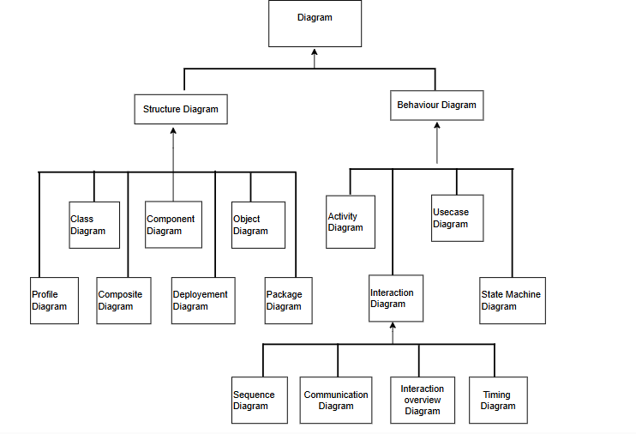

### Fig-5.3. Types and categories of UML diagrams

* 1. **Uml Diagrams**

The Unified Modeling Language (UML) is used to specify, visualize, modify, construct, and document the articrafts of an object-oriented software-intensive system under development. UML offers a standard way to visualize a system‘s architectural blueprints, including elements such as:

* Actors
* Business process
* (Logical) Components
* Activities
* Programming language statements
* Database schemas, and
* Reusable software components

The unified modeling language allows the software engineer to express an analysis model using the modeling notation that is governed by a set of syntactic-semantic and pragmatic rules. A UML system is represented using 5 different views that describe the system from distinctly different perspectives. Each view is defined by a set of diagrams, which are as follows:

### User Model View:

* This view represents the system from the user‘s perspective.
* The analysis describes a usage scenario from the end-user's perspective.
* The UML user model view encompasses the models that define a solution to a prob-lem as understood by the client stakeholders.

### Structural Model View:

* In this model the functionality is arrived from inside the system.
* This model view models the static structures.

### Behavioral Model View:

* It represents the dynamic of behavior as parts of the system, depicting the interactions of collection between various structural elements described in the user model and structural model view. It also aids in identifying potential bottlenecks, inefficiencies, or inconsistencies in the behavioral flow of the system.

### Implementation Model View:

* The implementation view is also known as the Architectural view which typically captures the enumeration of all the subsystems in the implementation model, the component diagrams illustrating how subsystems are organized in layers and hierarchies, and illustrations of import dependencies between subsystems.

### Environmental Model View:

* These UML models describe both structural and behavioral dimensions of the domain or environment in which the solution is implemented. This view is often also referred to as the deployment or physical view.

### Use case Diagram

**Fig-5.4.1. Use Case Diagram**

A flow of events is a sequence of transactions performed by the system. They typically contain very detailed information, written in terms of what the system should do not how the system accomplishes the task flow of events are created as separate files or documents in your favorite text editor and then attached or linked to the use case using the files or documents in your favorite text editor and then attached or linked to a use case using the files tab of a model element.

Use case diagrams are usually referred to as behavior diagrams used to describe a set of actions (use cases) that some systems should or can perform in collaboration with one or more external users of the system (actors).

### Activity Diagram

**Fig-5.4.2. Activity Diagram**

Activity Diagrams are graphical representations of Workflow of stepwise activities and actions with support for choice, iteration, and concurrency. In the Unified Modelling Language, activity diagrams can be used to describe the business and operational step- by-step workflows of components in a system. An activity diagram shows the overall flow of control.

### Sequence Diagram

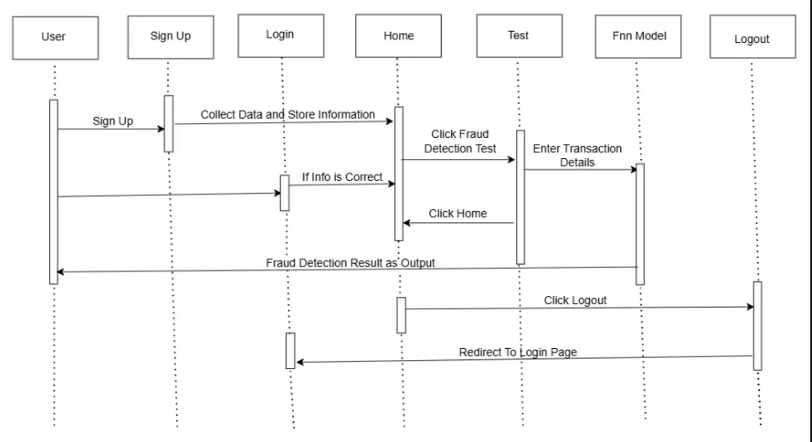A sequence diagram in UML is a kind of interaction diagram that shows how the process operates with one another and in what order. It is a construct of the Message Sequence Chart. A sequence diagram shows, as parallel vertical lines (―lifelines‖), different processes or objects that live simultaneously, and, as horizontal arrows, the messages exchanged between them, in the order in which they occur. This allows the specification of simple runtime scenarios in a graphical manner.

### Fig-5.4.3. Sequence Diagram

* + 1. **Component Diagram**

Component diagrams are used to display various components of a software system as well as subsystems of a single system. They are used to represent physical things or components of a system. It generally visualizes the structure and organization of a system. These diagrams help in understanding how different components interact and are connected, making them crucial for planning and implementing system architecture. They also show the dependencies between software components, helping developers identify reusable components and streamline the development process.

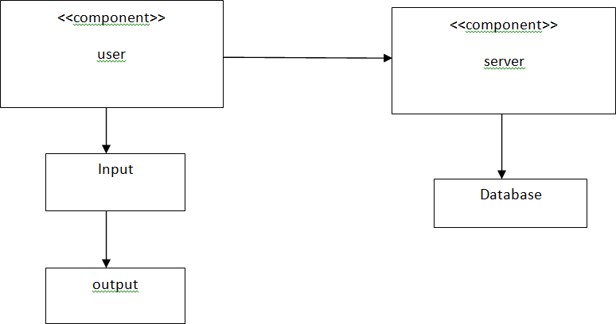

### Fig-5.4.4 Component Diagram

* + 1. **Deployment Diagram:**

A deployment diagram is a type of diagram that specifies the physical hardware on which the software system will execute. It also determines how the software is deployed on the underlying hardware.

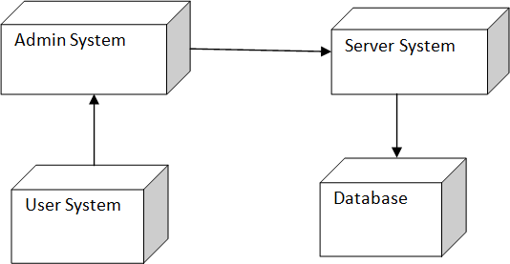

**Fig-5.4.5. Deployment Diagram**

**5.3 Algorithm:**

**Algorithm for Proposed Model: FNN-Based UPI Payment Fraud Detection**

**Step 1: Dataset Selection**

* Identify and select a suitable dataset containing transaction features such as transaction amount, sender ID, receiver ID, transaction time, location, device type, and previous transaction history ensuring it includes both fraudulent and legitimate transactions for accurate model training.

**Step 2: Data Preprocessing**

* Handle missing values using imputation techniques.
* Normalize numerical features using Min-Max Scaling or Standardization.
* Encode categorical variables using one-hot encoding or label encoding.

**Step 3: Data Augmentation**

* Since fraudulent transactions are often rare, apply data augmentation techniques to balance the dataset:
* **Synthetic Minority Over-sampling Technique (SMOTE)** to generate synthetic fraudulent samples.

**Step 4: Train-Test Split**

* Split the dataset into Training (80%) and Testing (20%) sets.

**Step 5: Model Selection (FNN for Fraud Detection)**

* Choose the Fully Connected Neural Network (FNN) model due to its ability to capture complex transaction patterns.
* Define the architecture with input, hidden, and output layers, using ReLU activation for hidden layers and Sigmoid for the output layer.

**Step 6: Forward Propagation Computation**

* Compute weighted sums and activations:

**Z=W⋅X+B**

# **A=f(Z)**

# **Where :**

* W weight matrix,
* X is the input feature vector,
* B is the bias term,
* Z=W⋅X+BZ is the linear transformation,
* A=f(Z) is the activation output with f(Z) as the activation function (e.g., ReLU)

**Step 7: Loss Function (Binary Cross-Entropy**)

* Use Binary Cross-Entropy Loss for fraud classification:

**Step 8: Model Training & Optimization**

* Train the FNN model using optimization techniques like Adam or Stochastic Gradient Descent (SGD).
* Use Backpropagation to adjust weights based on loss minimization.
* Implement Dropout Regularization to prevent overfitting.

**Step 9:** Evaluate the model's performance on Testing Data using accuracy, precision, recall, and F1-score.

**Step 10:** Use the Streamlit framework for developing the web application due to its simplicity and efficiency in deploying deep learning models.

**Step 11**: Implement the backend logic to handle user inputs, process transaction requests, and interact with the trained FNN model.

**Step 12:** Design and develop the User Interface (UI) for users to input transaction details like amount, sender details, and receiver details.

**Step 13:** Integrate the trained FNN model into the web application to classify transactions as fraudulent or legitimate.

**Step 14:** Deploy the web application, making it accessible to users over the internet, allowing real-time fraud detection.

**Step 15:** Users enter transaction details via the web interface, which are then processed by the system.

**Step 16:** The system predicts whether the transaction is fraudulent or safe based on the FNN model’s output.

**Step 17: Fraud Detection Result Display**

* Display the fraud detection result to the user with messages such as:
* “Transaction is Safe” (Legitimate)
* “Potential Fraud Detected!” (High Risk)

.

**CHAPTER 6**

**IMPLEMENTATION**

## CHAPTER 6

**IMPLEMENTATION**

* 1. **Steps For Implementation Implementation on Python** What is a Script?

A script or scripting language is a computer language with a series of commands within a file that is capable of being executed without being compiled .This is a very useful capability that allows us to type in a program and to have it executed immediately in an interactive mode.

* + - Scripts are reusable
    - Scripts are editable

### Difference between a script and a program Script:

Scripts are distinct from the core code of the application, which is usually written in a different language, and are often created or at least modified by the end-user. Scripts are often interpreted from source code or byte code, whereas the applications they control are traditionally compiled to naïve machine code.

### Program:

The program has an executable from that the computer can use directly to execute the instructions. The same program in its human-readable source code form, from which executable programs are derived (e.g., compiled).

### Python:

What is Python? Python is an interpreter, high-level, general-purpose programming language. It supports multiple programming paradigms, including procedural, object- oriented, and functional programming.

### Python concepts:

### Python is a high-level, interpreted, interactive and object-oriented scripting language.

### Python is designed to be highly readable.

### It uses English keywords frequently whereas other languages use punctuation, and it has fewer syntactical constructions than other languages.

* Python is interpreted – Python is processed at runtime by the interpreter. You do not need to compile your program before executing it. This is like PERL and PHP.
* Python is Interactive - You can actually sit at a Python prompt and interact with the interpreter directly to write your programs.
* Python is Object-Oriented – Python supports Object-Oriented style or technique of programming that encapsulates code within objects.
* Python is a Beginner’s Language – Python is a great language for the beginner- level.
* programmers and supports the development of a wide range of applications from simple text processing to WWW browsers to games.

### History of Python

Python was developed by Guido van Rossum in the late eighties and early nineties at the National Research Institute for Mathematics and Computer Science in the Netherlands.

Python is derived from many other languages, including ABC, Modula-3, C, C++, Algol-68, Smalltalk, and Unix shell and Other scripting languages.

Python is copyrighted. Like Perl, Python source code is now available under the GNU General Public License (GPL).

Python is now maintained by a core development team at the institute, although Guido van Rossum still holds a vital role in directing its progress.

### Python Features

python ‘s features include

* Easy-to-learn: Python has few keywords, simple structure, and a clearly defined syntax. This allows the student to pick up the language quickly.
* Easy-to-read: Python code is more clearly defined and visible to the eyes.
* Easy-to-maintain: Python ‘s source code is easy-to-maintain.
* A broad standard library: Python ‘s bulk of the library is very portable and cross platform compatible on Macintosh.
* Interactive Mode: Python has support for an interactive mode which allows interactive testing and debugging of snippets of code.
* Portable: Python can run on a wide variety of hardware platforms and has the same interface on all platforms.
* Extensible: You can add low-level modules to the Python interpreter. These modules enable programmers to add to or customize their tools to be more efficient.
* Databases: Python provides interfaces to all major commercial databases.
* GUI Programming: Python supports GUI applications that can be created and ported to many system calls, libraries and windows systems, such as Windows MFC, Macintosh, and the X Window system of Unix.
* Scalable: Python provides better structure and support for large programs than shell scripting.

### Python modules:

Python allows us to store our code in files (also called modules). To support this, Python has a way to put definitions in a file and use them in a script or in an interactive instance of the interpreter. Such a file is called a module; definitions from a module can be imported into other module or into the main module.

### Testing code:

* Code is usually developed in a file using an editor.
* To test the code, import it into a python session and try to run it.
* Usually there is an error, so you can check by go to file, make a correction, and test again. This process is repeated until you are satisfied that the code works. The entire process is known as the development cycle.

### Implementation of Deep Learning

The implementation steps for Deep learning can vary depending on the specific task, dataset, and algorithm you're working with. However, here's a general outline of the steps involved in a typical Deep learning project:

**Define the Problem:** Clearly understand and define the problem you are trying to solve. What is the goal of your Deep learning model? What are you trying to predict or classify?

**Gather Data:** Collect relevant data that will be used to train and evaluate your model. This could involve acquiring data from various sources such as databases, APIs, or data files.

**Data Preprocessing:**

**Data Cleaning**: Handle missing values, outliers, and other inconsistencies in the data.

**Feature Selection/Engineering:** Select relevant features and potentially create new features that might improve model performance.

**Normalization/Standardization:** Scale the features to a similar range to ensure they contribute equally to the model.

**Split Data:** Divide your data into training, validation, and test sets. The training set is used to train the model, the validation set is used to tune hyperparameters and evaluate different model variations, and the test set is used to evaluate the final model performance.

**Choose a Model:** Select an appropriate Deep learning algorithm based on the problem you are trying to solve and the characteristics of your data. This could be regression, classification, clustering, etc.

**Train the Model:** Feed the training data into the chosen model and optimize its parameters to minimize the error between predicted and actual outcomes. This is typically done through an optimization algorithm like gradient descent.

**Validate the Model:** Use the validation set to evaluate the performance of the trained model. Adjust hyperparameters or try different algorithms as necessary to improve performance.

**Evaluate the Model**: Once you're satisfied with the model's performance on the validation set, evaluate it on the test set to get an unbiased estimate of its performance.

**Hyperparameter Tuning**: Fine-tune the model's hyperparameters to further improve its performance. This could involve techniques like grid search, random search, or more advanced optimization algorithms.

**Deploy the Model:** If the model performs satisfactorily, deploy it to a production environment where it can make predictions on new, unseen data. This might involve integrating the systems or applications.

**Monitor and Maintain:** Continuously monitor the model's performance in production and update it as necessary to account for changing data distributions or other factors that might affect its accuracy.

**Documentation:** Document the entire process including data sources, preprocessing steps, model selection, training procedure, evaluation metrics, and any other relevant information. This documentation is crucial for reproducibility and knowledge transfer.

**Implementation of Streamlit using Deep Learning**

Implementing Streamlit with Deep Learning involves integrating Deep learning models into a streamlit web application.

**Setup Streamlit Project:**

Install Streamlit if you haven't already: pip install Streamlit. Create a new Streamlit project: -admin startproject myproject. Navigate to the project directory: cd myproject

**Prepare Deep Learning Model:**

Train and save your Deep learning model using libraries like scikit-learn, TensorFlow, or PyTorch. Serialize the trained model using joblib, pickle, or TensorFlow's SavedModel format.

**Define Views:**

Create views in your Streamlit app that will handle the incoming requests and responses. For example, you might have a view that renders a form for users to input data, and another view that processes the form data and returns predictions from the machine learning model.

**Create Templates:**

Design HTML templates to render the web pages. These templates will contain forms for user input and display the results returned by the views.

**Define URLs:**

Configure URL patterns in the urls.py file of your Streamlit app to map URLs to the corresponding views. Specify the URLs where users can access the machine learning functionality within your web application.

**Design Streamlit Interface**

Create an interactive and user-friendly interface using Streamlit’s built-in UI components. Use titles, headers, and markdown styling to guide users. Implement sections for uploading images, displaying results, and providing relevant information about the disease being analyzed.

**Load and Integrate the Deep Learning Model**

Use Streamlit’s caching mechanism to efficiently load the trained deep learning model. The model should be loaded only once to reduce latency and improve application performance.

**Upload and Process Input Data**

Allow users to upload medical images in standard formats like JPG and PNG. Resize and normalize images before feeding them into the deep learning model. Ensure the uploaded files are displayed properly before making predictions.

**Integrate Deep Learning Model:**

Load the serialized machine learning model in your Streamlit views. Use the model to make predictions based on the input data received from the user.

**Test:**

Test your Streamlit web application locally to ensure that everything is working as expected. Submit sample data through the forms and verify that the predictions returned by the machine learning model are accurate.

**Deploy:**

Once you're satisfied with the functionality of your Streamlit web application, deploy it to a web server or platform such as Heroku, AWS, or PythonAnywhere. Make sure to include any necessary dependencies, such as the machine learning libraries, in your deployment environment.

**Monitor and Maintain:**

Monitor your deployed application for any errors or performance issues. Update the machine learning model as needed with new data or retraining to improve accuracy over time.

#### **6.2 CODING**

#### **DEEP LEARNING CODE**

#### **Import Necessary Libraries**

#### import pandas as pd

#### import random

#### import tensorflow as tf

#### from sklearn.utils import resample

#### from sklearn.model_selection import train_test_split

#### from sklearn.preprocessing import StandardScaler, LabelEncoder

#### from tensorflow.keras.models import Sequential

#### from tensorflow.keras.layers import Dense, Dropout, BatchNormalization

#### from tensorflow.keras.callbacks import ReduceLROnPlateau, EarlyStopping

#### from sklearn.utils.class_weight import compute_class_weight

#### from sklearn.metrics import classification_report, confusion_matrix

#### import numpy as np

#### import matplotlib.pyplot as plt

#### import seaborn as sns

#### **Define F1 Score Metric**

#### precision = tf.keras.metrics.Precision()

#### recall = tf.keras.metrics.Recall()

#### def f1_score_metric(y_true, y_pred):

#### precision.update_state(y_true, y_pred)

#### recall.update_state(y_true, y_pred)

#### precision_value = precision.result()

#### recall_value = recall.result()

#### f1_score = 2 * ((precision_value * recall_value) / (precision_value + recall_value + tf.keras.backend.epsilon()))

#### precision.reset_state()

#### recall.reset_state()

#### return f1_score

#### **Load and Preprocess Dataset**

#### file_path = "Upi_fraud_dataset.csv"

#### df = pd.read_csv(file_path)

#### print(df.head())

#### df.info()

#### # Encode categorical variables

#### label_encoder = LabelEncoder()

#### df['transaction_type'] = label_encoder.fit_transform(df['transaction_type'])

#### df['device_type'] = label_encoder.fit_transform(df['device_type'])

#### df['location'] = label_encoder.fit_transform(df['location'])

#### # Handle missing values

#### df.fillna(df.mean(), inplace=True)

#### # Feature Scaling

#### scaler = StandardScaler()

#### features = df.drop(columns=['is_fraud'])

#### labels = df['is_fraud']

#### scaled_features = scaler.fit_transform(features)

#### **Data Augmentation (Oversampling for class imbalance)**

#### fraud_df = df[df['is_fraud'] == 1]

#### non_fraud_df = df[df['is_fraud'] == 0]

#### fraud_upsampled = resample(fraud_df, replace=True, n_samples=len(non_fraud_df), random_state=42)

#### df_balanced = pd.concat([non_fraud_df, fraud_upsampled])

#### # Shuffle the dataset

#### df_balanced = df_balanced.sample(frac=1, random_state=42).reset_index(drop=True)

#### **Split into Training and Testing Sets**

#### x_train, x_test, y_train, y_test = train_test_split(scaled_features, labels, test_size=0.2, random_state=42)

#### **Define FNN Model**

#### def build_fnn():

#### model = Sequential([

#### Dense(64, activation='relu', input_shape=(x_train.shape[1],)),

#### BatchNormalization(),

#### Dropout(0.3),

#### Dense(32, activation='relu'),

#### Dropout(0.2),

#### Dense(1, activation='sigmoid')

#### ])

#### return model

#### model = build_fnn()

#### model.compile(optimizer=tf.keras.optimizers.Adam(learning_rate=0.001),

#### loss='binary_crossentropy',

#### metrics=['accuracy', precision, recall, f1_score_metric])

#### **Train Model**

#### es = EarlyStopping(monitor='val_loss', patience=5, verbose=1, restore_best_weights=True)

#### lr = ReduceLROnPlateau(monitor='val_loss', factor=0.2, patience=3, verbose=1)

#### history = model.fit(x_train, y_train, epochs=20, batch_size=32, validation_data=(x_test, y_test), callbacks=[es, lr])

#### **Evaluate Model Performance**

#### y_pred = model.predict(x_test)

#### y_pred_classes = (y_pred > 0.5).astype(int)

#### print(classification_report(y_test, y_pred_classes))

#### Confusion Matrix

#### cm = confusion_matrix(y_test, y_pred_classes)

#### sns.heatmap(cm, annot=True, fmt='d', cmap='Blues')

#### plt.xlabel('Predicted')

#### plt.ylabel('Actual')

#### plt.title('Confusion Matrix')

#### plt.show()

#### **Streamlit Code**

1. **Import necessary libraries**

import streamlit as st

import numpy as np

import pandas as pd

1. **Set up Streamlit app**

st.set_page_config(page_title="UPI Fraud Detection",page_icon="💳", layout="wide")

1. **Function to simulate fraud detection model**

@st.cache_resource

def load_trained_model():

try:

# Placeholder for loading an actual ML model

return "Mock Model Loaded"

except Exception as e:

st.error(f"Error loading model: {e}")

return None

1. **Function to process transaction input**

def preprocess_transaction(amount, category, transaction_type, latitude, longitude, avg_amount, unusual_loc, unusual_amt, new_device, failed_logins):

return np.array([[amount, category, transaction_type, latitude, longitude, avg_amount, unusual_loc, unusual_amt, new_device, failed_logins]])

1. **Function to predict fraud (mock logic for now)**

def predict_fraud(transaction_data):

return "Fraud Detected" if transaction_data[0][0] > 5000 else "No Fraud Detected"

1. **Custom CSS Styling**

st.markdown("""

<style>

.main {background-color: #f0f5f9;}

.stButton>button {width: 100%; border-radius: 6px; font-size: 18px; padding: 10px;}

.header {text-align: center; font-size: 28px; font-weight: bold; color: #004080;}

.subheader {text-align: center; font-size: 20px; font-weight: bold; color: #0080ff;}

</style>

""", unsafe_allow_html=True)

1. **Function to run the app**

def main():

model = load_trained_model()

st.markdown("<h1 class='header'>UPI Fraud Detection System</h1>", unsafe_allow_html=True)

st.subheader("Enter Transaction Details")

amount = st.number_input("Transaction Amount", min_value=0, value=1000)

category = st.selectbox("Transaction Category", ["Electronics", "Restaurants", "Groceries", "Clothing", "Entertainment", "Utilities", "Travel"])

transaction_type = st.selectbox("Transaction Type", ["P2M", "P2P"])

latitude = st.text_input("Latitude", "0.0")

longitude = st.text_input("Longitude", "0.0")

avg_amount = st.number_input("Average Transaction Amount", min_value=0, value=1000)

unusual_loc = st.checkbox("Unusual Location")

unusual_amt = st.checkbox("Unusual Amount")

new_device = st.checkbox("New Device")

failed_logins = st.number_input("Failed Login Attempts", min_value=0, value=0)

if st.button("Analyze Transaction"):

transaction_data = preprocess_transaction(amount, category, transaction_type, latitude, longitude, avg_amount, unusual_loc, unusual_amt, new_device, failed_logins)

result = predict_fraud(transaction_data)

st.success(f"Fraud Status: {result}")

st.subheader("UPI Fraud Detection Results")

transaction_history = pd.DataFrame({

"Transaction ID": [101, 102, 103],

"Amount": [500, 7000, 3000],

"Transaction Time": ["12:00 PM", "1:30 PM", "3:00 PM"],

"User Location": ["Hyderabad", "Mumbai", "Delhi"],

"Device Type": ["Mobile", "Laptop", "Tablet"],

"Bank": ["SBI", "HDFC", "ICICI"],

"Fraud Status": ["No Fraud", "Fraud Detected", "No Fraud"]

})

st.table(transaction_history)

**CHAPTER 7 TESTING**

### CHAPTER 7 SYSTEM TESTING

* 1. **Testing**

### The purpose of testing UPI fraud detection is to identify errors, vulnerabilities, and weaknesses in the fraud detection model. Testing ensures that the Fully Connected Neural Network (FNN) effectively detects fraudulent transactions while minimizing false positives and negatives. It verifies whether the model meets its performance requirements and user expectations without failing in an unacceptable manner.

### Manual Testing:

### Manual testing includes evaluating the UPI fraud detection system without using automated tools or scripts. In this approach, the tester takes on the role of an end-user, simulating real-world transactions to identify unexpected behaviors, vulnerabilities, or errors in the fraud detection model. This ensures that fraudulent activities are accurately detected while minimizing false positives and negatives. There are different stages for manual testing such as unit testing, integration testing, system testing, and user acceptance testing.

### Automation Testing:

Automation testing, which is also known as Test Automation, is when the tester writes scripts and uses another software to test the product. This process involves automation of a manual process. Automation Testing is used to re-run the test scenarios that were performed manually, quickly, and repeatedly.

### What to Automate?

It is not possible to automate everything in a software. The areas at which a user can make transactions such as the login form or registration forms, any area where large number of users can access the software simultaneously should be automated.

### When to Automate?

Test Automation should be used by considering the following aspects of a software

* Large and critical projects
* Projects that require testing the same areas frequently
* Requirements not changing frequently
* Accessing the application for load and performance with many virtual users
* Stable software with respect to manual testing
* Availability of time

### How to Automate?

Automation is done by using a supportive computer language like VB scripting and an automated software application. There are many tools available that can be used to write automation scripts. Before mentioning the tools, let us identify the process that can be used to automate the testing process –

* Identifying areas within software for automation
* Selection of appropriate tool for test automation
* Writing test scripts
* Development of test suits
* Execution of scripts
* Create result reports
* Identify any potential bug or performance issue

### Types Of Tests

* + 1. **Unit Testing**

Unit testing involves the design of test cases that validate that the internal program logic is functioning properly, and that program inputs produce valid outputs. All decision branches and internal code flow should be validated. It is the testing of individual software units of the application. it is done after the completion of an individual unit before integration. This is structural testing, that relies on knowledge of its construction and is invasive. Unit tests perform basic tests at component level and test a specific business process, application, and/or system configuration. Unit tests ensure that each unique path of a business process performs accurately to the documented specifications and contains clearly defined inputs and expected results.

Unit testing is usually conducted as part of a combined code and unit test phase of the software lifecycle, although it is not uncommon for coding and unit testing to be conducted as two distinct phases.

Test strategy and approach:

* + - * Field testing will be performed manually and functional tests will be written in detail.
      * Test objectives
      * All field entries must work properly.
      * Pages must be activated from the identified link.
      * The entry screen, messages and responses must not be delayed.
      * Features to be tested:
      * Verify that the entries are of the correct format
      * No duplicate entries should be allowed
      * All links should take the user to the correct page.

### Integration Testing

Integration tests are designed to test integrated software components to determine if the actually run as one program. Testing is event driven and is more concerned with the basic outcome of screens or fields. Integration tests demonstrate that although the components were individually satisfaction, as shown by successfully unit testing, the combination of components is correct and consistent. Integration testing is specifically aimed at exposing the problems that arise from the combination of components.

Software integration testing is the incremental integration testing of two or more integrated software components on a single platform to produce failures caused by interface defects.

The task of the integration test is to check that components or software applications, e.g. components in a software system or – one step up – software applications at the company level – interact without error.

### Test Results

All the test cases mentioned above passed successfully. No defects encountered.

### Functional Testing

Functional tests provide systematic demonstrations that functions tested are available as specified by the business and technical requirements, system documentation, and user manuals.

Functional testing is centered on the following items:

**Valid Input:** identified classes of valid input must be accepted. **Invalid Input:** identified classes of invalid input must be rejected. **Functions:** identified functions must be exercised.

**Output:** identified classes of application outputs must be exercised.

**Systems/Procedures**: interfacing systems or procedures must be invoked.

Organization and preparation of functional tests is focused on requirements, key functions, or special test cases. In addition, systematic coverage pertaining to identify Business process flows; data fields, predefined processes, and successive processes must be considered for testing. Before functional testing is complete, additional tests are identified and the effective value of current tests is determined.

### System Testing

System testing ensures that the entire integrated software system meets requirements. It tests a configuration to ensure known and predictable results. An example of system testing is the configuration-oriented system integration test. System testing is based on process descriptions and flows, emphasizing pre-driven process links and integration points.

### White Box Testing

White Box Testing is a testing in which in which the software tester has knowledge of the inner workings, structure and language of the software, or at least its purpose. It is purpose. It is used to test areas that cannot be reached from a black box level.

### Black Box Testing

Black Box Testing is testing the software without any knowledge of the inner workings, structure or language of the module being tested. Black box tests must be written from a definitive source document, such as specification or requirements document, such asspecification or requirements document. It is a testing in which the software under test is treated, as a black box. you cannot ―see‖ into it. The test provides inputs and responds to outputs without considering how the software works.

### Test Cases Case 1:

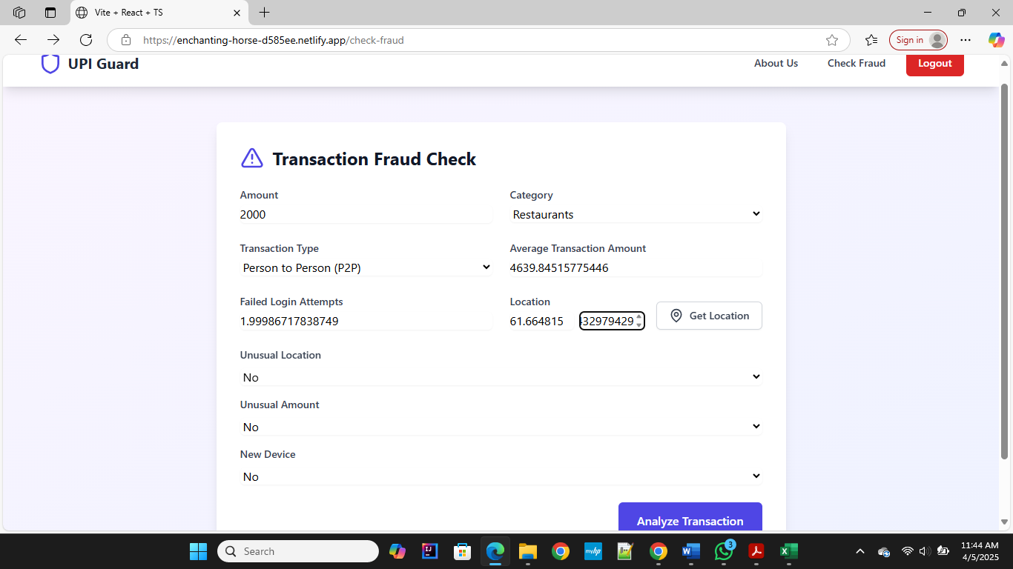This image displays the data input form of the UPI fraud detection system, where users enter transaction details and behavioral indicators for analysis. Key inputs include amount, type, category, location, and unusual activity flags, with an option to fetch location and analyze the transaction.

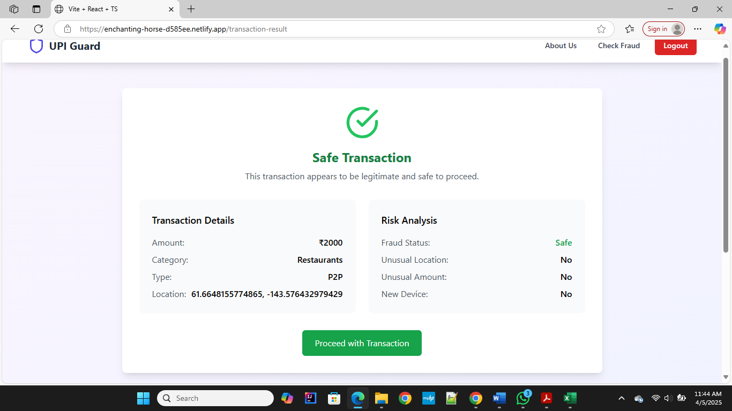**Case 1 Input**

**Case 1 Output**

**CHAPTER 8 RESULTS AND SCREENSHOTS**

## CHAPTER 8 RESULTS AND SCREENSHOTS

## SCREENSHOTS

The final results obtained are better by using a feed-forward neural network, a deep learning algorithm. The system begins with a homepage introducing users to UPI Guard, highlighting key features such as fraud detection, safe transactions, and advanced ML-powered security. This ensures users are aware of the platform's purpose in securing UPI transactions. From there, users can navigate to the fraud check page, where they input transaction details to predict the likelihood of fraud using intelligent analysis. It serves as an entry point, emphasizing real-time fraud detection and secure payment processing. It educates users on the system’s capabilities before guiding them to perform transaction analysis. This clear workflow enhances both usability and trust in the AI-powered UPI fraud detection system.

**Home Page**

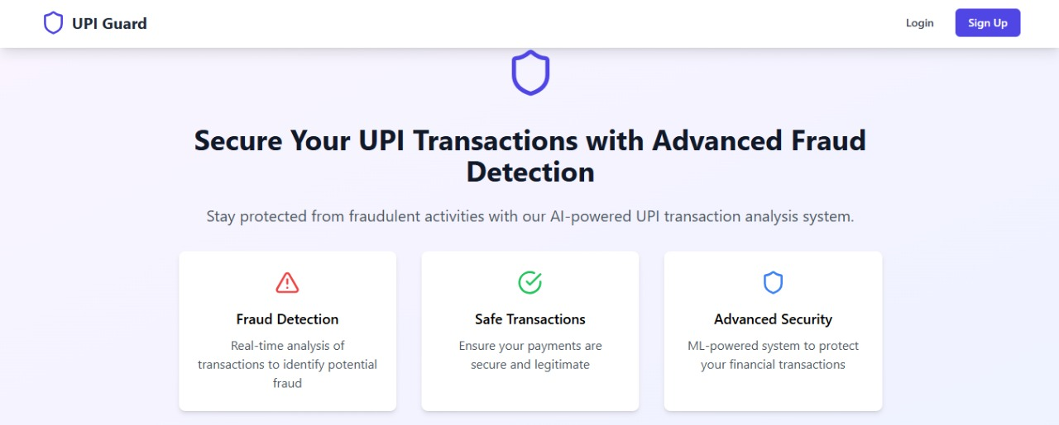

**Fig 8.1.1 Home Page**

**Sign Up Page**

This image displays the account creation interface of the UPI fraud detection system. Users are prompted to enter a username, email address, password, and confirm the password. Upon successful registration, a confirmation message appears, indicating that the account has been created and the user is being redirected to the login page.

**Fig 8.2.1 Sign Up Page**

**Login Page**

This image displays the login interface of the UPI fraud detection system. If the entered credentials are valid and the user is registered, successful login redirects them to the About Us page, where users can learn more about the system’s fraud detection capabilities**.**

**Fig 8.2.2 Login Page**

**About us page**

The "About UPI Fraud Detection" section highlights the system’s AI-powered capabilities to safeguard users from UPI payment fraud using real-time transaction analysis and machine learning algorithms. It lists common UPI fraud types such as phishing attacks, QR code scams, and remote access fraud, while also outlining protective measures like real-time analysis, location monitoring, and behavioral analysis to detect and prevent suspicious activities.

**Fig 8.1.2 About us Page**

**Test Page**

On this page, the user is required to provide values for transaction-related fields such as amount, type, category, number of failed logins, and location details. After entering all the necessary inputs, clicking on **Analyze Transaction** will redirect the user to the results page. Additionally, users can navigate to the home page at any time by clicking on **Home** in the top right corner.

**Fig 8.3.1 Test Page Result 1**

**Fg 8.3.2 Test Page Result 1**

**Result Page**

**On clicking the "Get Predictions" button**, you will be directed to the **Result** page where it displays whether the given UPI transaction is **fraudulent or legitimate** based on the input details you provided.

### Fig 8.4.1 Result Page 1

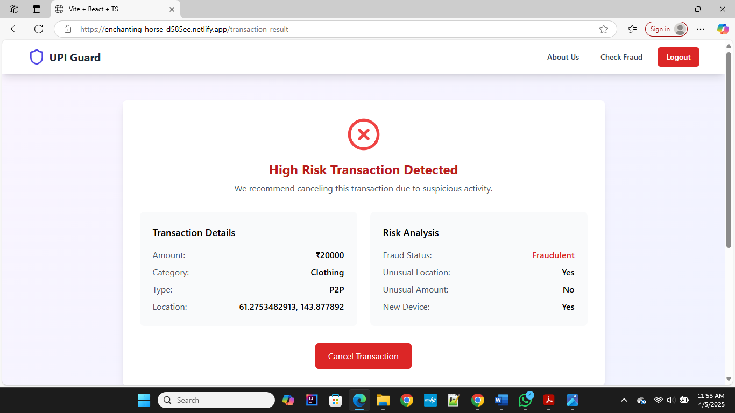

**Fig 8.4.2 Result Page 2**

**History Page**

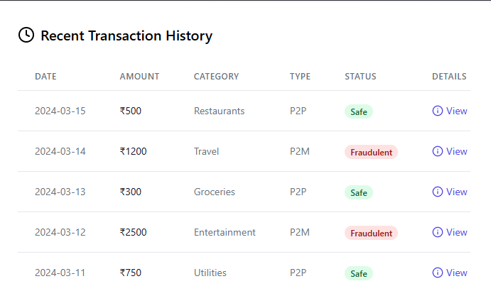The History page shows a list of all previous UPI transaction predictions with details like transaction ID, input data, result (fraud/legit), and date-time. It helps users track and review past checks. The View page allows users to see the complete details of a specific prediction for better understanding and analysis.

**Fig 8.5.1 History Page**

**Fig 8.5.1 View Page**

* 1. **Experimental Results**
     1. **Performance of Existing and proposed Models**

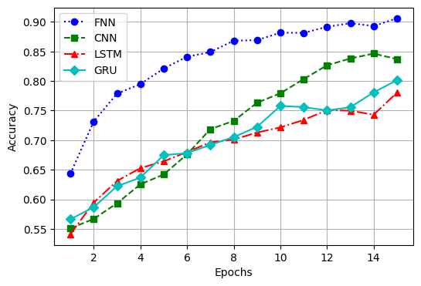 Where accuracy measures how good a model is with balanced data altogether, it could be misleading with unbalanced data. Precision, how good the model is at avoiding false positives, is calculated by the ratio of all true positive predictions made by it to all its positive predictions. Recall is the measure of how well a model identifies true positives. Then there are recall, precision, and F1 to be considered. Recall measures the sensitivity of a model; the F1 score is the mean of the precision and the recall of this to give a balance between them, which gives a more rounded view of the performance.Precision indicates how well the model avoids false positives, that is, how many of the transactions it predicted as fraudulent were fraudulent. It is calculated as the ratio of true positives to all positive predictions. Recall, on the other hand, reflects how well the model detects actual fraudulent cases, calculated as the ratio of true positives to all actual fraud instances. A high recall means fewer fraudulent transactions go undetected, which is critical in fraud detection scenarios.

**(a) Accuracy (b) Loss**

**Fig 8.6.1: Accuracy and Loss of different models**

**Fig-8.6.1(a)** depicts accuracy curves of four models, , FNN, CNN, LSTM, and GRU, for 100 epochs. The FNN model has the highest accuracy, beginning at approximately 0.60 and quickly rising to about 0.95 in the last epoch, which reflects better performance. The GRU model reflects slow but continuous improvement, reaching approximately 0.82 at the end of training. The CNN model exhibits a moderate rising trend, reaching about 0.77. At the same time, the LSTM model is worst at first at approximately 0.58 but rises steadily to almost 0.72. The FNN model generally does better than the others in all epochs.

**Fig-8.6.1(b)** illustrates the trends of loss of four models, FNN, CNN, LSTM, and GRU,

across 100 epochs. The FNN model exhibits the greatest loss decrease, beginning at approximately 0.50 and gradually declining to about 0.12, reflecting better optimization and learning efficiency. The LSTM model also exhibits a decreasing trend, decreasing its loss from approximately 0.48 to 0.32. The CNN model keeps a comparatively constant loss, oscillating around 0.45–0.50, representing slower improvement. The worst performance is by the GRU model, where loss values stay above 0.50 throughout all the epochs, registering little decrease. Generally, the FNN model realizes the lowest loss, affirming its better performance compared to the other models.

**Fig-8.6.2(a)** illustrates the precision curves of four models, FNN, CNN, LSTM, and GRU, for 100 epochs. The FNN model shows the best precision, beginning at approximately 0.65 and gradually increasing to almost 0.97 by the last epoch, reflecting its good classification capability. The LSTM model shows a consistent upward trend, reaching approximately 0.90, reflecting good precision. The CNN model starts with the lowest precision at around 0.42, increases steadily and peaks at around 0.75 but with fluctuation. The GRU model begins around 0.50 and continues to increase steadily to around 0.72. The overall performance of the FNN model is the best among the others, with better precision in all epochs.\

**Fig-8.6.2(b)** shows the trends in recall of four models, FNN, CNN, LSTM, and GRU, for 100 epochs. The FNN model has the maximum recall, which begins at approximately 0.65 and continues to grow steadily up to about 0.90, reflecting its better capability to effectively identify positive examples. The GRU model has a moderate increasing trend, from approximately 0.45 to about 0.65 at the last epoch. The LSTM model begins at a lower recall value near 0.15 but slowly increases to around 0.38, indicating slow improvement. The CNN model maintains the lowest recall, which varies during training and reaches a peak of only around 0.30. Generally, the FNN model performs better than the remaining models in recall throughout the whole epochs. Overall, the FNN demonstrates superior learning efficiency and strong generalization for positive class detection across all epochs, making it the most promising model for real-time UPI fraud detection. The performance gap also emphasizes the importance of choosing the right architecture based on data characteristics and application domain. Future work may explore hybrid architectures or ensemble techniques to leverage the strengths of multiple models for even better recall and overall classification performance.

**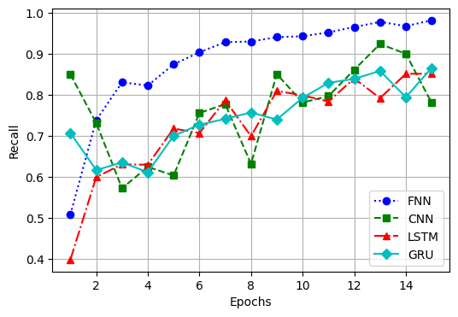 (a) Precision (b) Recall**

**(c) F1-Score**

**Fig 8.6.2 Precision recall and F1-Score curve of different models**

**Fig-8.6.2(c)** shows the trend of F1-scores for four models, FNN, CNN, LSTM, and GRU, in 100 epochs. The highest F1-score is achieved by the FNN model, beginning with around 0.75 and continuously increasing towards almost 0.98, showing an excellent balance between recall and precision. The trend for the LSTM model is mild and upward, starting at about 0.50 and achieving around 0.70 towards the last epoch. The GRU model begins around 0.20 but works its way higher to a point of about 0.40, albeit inconsistently. The CNN model scores the lowest and has inconsistent increases with fluctuations before reaching a height of about 0.30. The FNN model performs higher than the others in F1-score for every epoch.

* + 1. **Confusion matrix of existing and proposed models**

We assess our proposed models against state-of-the-art alternatives with the help of confusion matrices. The latter provides detailed breakdowns regarding classification performance, namely, true positives, false positives, true negatives, and false negatives. Those metrics enable good quantitative assessment of accuracy and precision of the models, their recalls, and further, their classification ability. The confusion matrix helps identify the strengths and weaknesses of a model—whether it is more prone to false alarms (high FP) or failing to detect actual frauds (high FN). For fraud detection systems, minimizing false negatives is particularly critical, as undetected fraud can lead to financial losses. Therefore, in addition to accuracy, more emphasis is placed on recall and precision, with the F1 score serving as a harmonic mean to balance both. Moreover, comparing confusion matrices across models such as FNN, CNN, LSTM, and GRU reveals how each algorithm responds to different transaction patterns. For instance, a model with high TP and low FP values indicates a strong ability to correctly flag fraud while minimizing inconvenience to legitimate users. Such insights from the confusion matrix not only guide model selection and tuning but also play a vital role in making informed decisions about deploying fraud detection systems in real-world environments where both security and user experience are critical.

**Fig-8.6.3(a)** shows the performance of a classification model to identify fraudulent transactions. It provides a detailed breakdown of the model’s predictive accuracy by displaying the number of true positives, true negatives, false positives, and false negatives. The x-axis represents the predicted classes, and the y-axis represents the actual classes, with labels divided into “Fraud” and “Non-Fraud.” The model successfully identified 1544 non-fraudulent transactions as non-fraud (true negatives) and 1757 fraudulent transactions as fraud (true positives), demonstrating high reliability in recognizing both classes. However, the model incorrectly labelled 263 non-fraudulent transactions as fraud (false positives), which could lead to inconvenience for genuine users. Additionally, it failed to detect 50 fraudulent transactions and predicted them as non-fraud (false negatives), which could be a risk in real-world financial systems.

**Fig-8.6.3 (b)** illustrates the performance of a classification model used to detect fraudulent transactions. It divides predictions into four categories: true positives, true negatives, false positives, and false negatives. Along the x-axis are the predicted classes, and along the y-axis are the actual classes, categorized as “Fraud” and “Non-Fraud.” According to the matrix, the model accurately predicted 1534 non-fraud cases as non-fraud (true negatives) and 1542 fraud cases as fraud (true positives), indicating strong learning capability. On the other hand, the model incorrectly classified 273 non-fraud cases as fraud (false positives) which might result in unnecessary alerts or user inconvenience. Additionally, it failed to identify 265 fraud cases, wrongly labeling them as non-fraud (false negatives), which poses a potential security risk. These misclassifications suggest a need for improving the model’s sensitivity and specificity. The matrix employs a gradient color scale ranging from light to dark blue to indicate the frequency of predictions, with darker shades representing a higher concentration of data 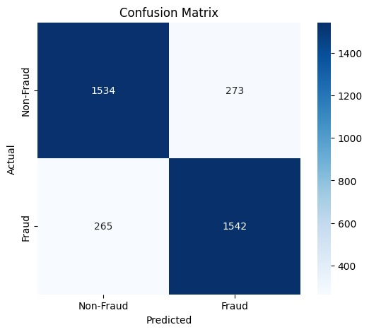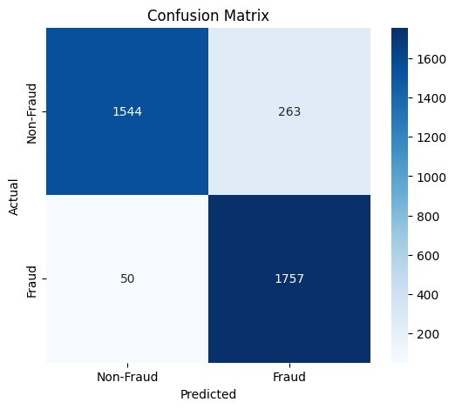points

**(a)FNN (b) CNN**

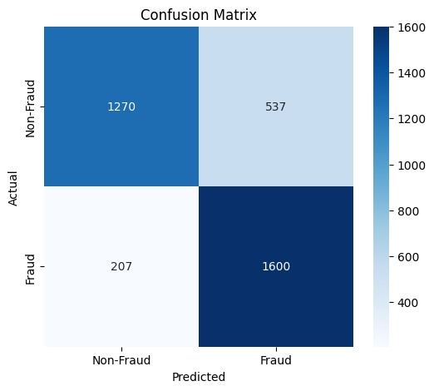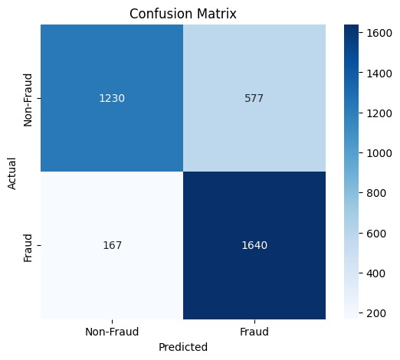

**(c) LSTM (d) GRU**

**Fig 8.6.3 Confusion Matrix of different models**

**Fig-8.6.3 (c)** shows the performance of a fraud detection model with actual labels on the y-axis and predicted labels on the x-axis. The model accurately classified 1230 non-fraud cases (true negatives) and 1640 fraud cases (true positives), indicating strong detection ability. However, it misclassified 577 non-fraud cases as fraud (false positives), which may lead to unnecessary alerts. Additionally, 167 fraud cases were incorrectly labeled as non-fraud (false negatives), raising security concerns. The matrix uses darker colors to represent correct predictions and lighter shades for errors. The right-side color bar indicates the intensity of values. While the model shows good overall accuracy, the false positive rate is still relatively high. Reducing these misclassifications is important to avoid user dissatisfaction. The model is effective but requires further tuning. Optimizing precision would make it more suitable for real-world fraud detection.

**Fig-8.6.3 (c)** shows the performance of a fraud detection model with actual labels on the y-axis and predicted labels on the x-axis. The model accurately classified 1230 non-fraud cases (true negatives) and 1640 fraud cases (true positives), indicating strong detection ability. However, it misclassified 577 non-fraud cases as fraud (false positives), which may lead to unnecessary alerts. Additionally, 167 fraud cases were incorrectly labeled as non-fraud (false negatives), raising security concerns. The matrix uses darker colors to represent correct predictions and lighter shades for errors. The right-side color bar indicates the intensity of values. While the model shows good overall accuracy, the false positive rate is still relatively high. Reducing these misclassifications is important to avoid user dissatisfaction. The model is effective but requires further tuning. Optimizing precision would make it more suitable for real-world fraud detection.

**Fig-8.6.3 (d)** illustrates the effectiveness of a fraud detection model, highlighting the distribution of correct and incorrect predictions. The model accurately identified 1230 non-fraudulent transactions as non-fraud (true negatives) and 1640 fraudulent transactions as fraud (true positives), indicating strong detection performance. However, it misclassified 577 legitimate transactions as fraud (false positives), which could lead to unnecessary user alerts or inconvenience. Additionally, 167 fraudulent transactions were mistakenly labeled as non-fraud (false negatives), representing a significant risk as these may go undetected. The matrix is color-coded, with darker shades indicating higher accuracy in true predictions and lighter shades representing misclassifications. The vertical axis displays actual classes, while the horizontal axis shows predicted classes, and a color bar to the side visualizes frequency intensity. The dominance of darker diagonal cells confirms the model's strong predictive

#### **8.6.4 ROC Curves of Existing and Proposed Models**

Receiver Operating Characteristic (ROC) and Precision-Recall curves are fundamental assessment tools to measure the performance of classification models, especially those that deal with imbalanced datasets. The ROC curve plots a graph of True Positive Rate (Sensitivity) against False Positive Rate, which gives a holistic view of the ability of the model to distinguish between classes at different thresholds. The Area Under Curve (AUC) AUC-ROC is a scalar measure of total overall performance, and a larger value implies better discriminative capacity. For this reason, and in contrast to the PR curve, which is centered on the balance between precision and recall (sensitivities), it is more informative for classes that dominate.

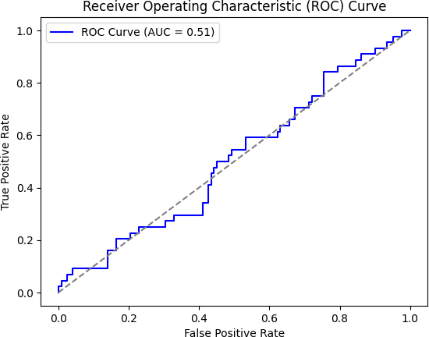**Fig 8.6.4(a)** shows a ROC (Receiver Operating Characteristic) curve, which measures the performance of a FNN (Fully Connected Neural Network) classification model. The x-axis represents the False Positive Rate (FPR), while the y-axis indicates the True Positive Rate (TPR). The ROC curve illustrates the trade-off between sensitivity (recall) and specificity, helping to evaluate the model's ability to distinguish between classes.The blue line on the graph shows how effectively the model can separate the positive and negative classes. The Area Under the Curve (AUC) is 0.96, which signifies an outstanding classification performance. An AUC value of 1.0 represents a perfect classifier, while an AUC of 0.5 suggests random guessing without any discriminative power. Since the AUC is 0.96, the model performs very well in separating the classes, with minimal misclassification. This indicates that the FNN is highly reliable for the given dataset. Moreover, the closer the curve follows the top-left border of the ROC space, the better the model's performance.

**(a) FNN (b) CNN**

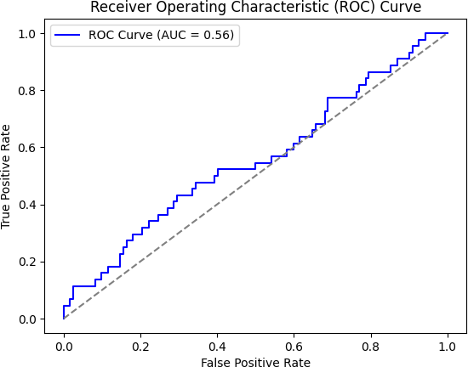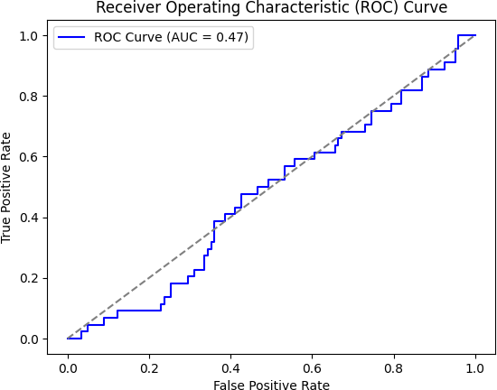

**(c) GRU (d) LSTM**

**Fig 8.6.4 ROC Curves of different Models**

**Fig 8.6.4(b)** contains a ROC curve, which calculates the performance of a CNN classification model. The FPR is represented by the x-axis, and TPR is represented on the y-axis. The model's classification accuracy is plotted in blue, and the AUC is 0.51, which is so close to 0.5. An AUC of 0.5 implies a model with no better than random guessing capability, whereas the best model should have an AUC of 1.0. As the provided AUC is 0.51, the performance of the model is just marginally better than that of random classification, which could imply that the model needs adjustments in feature choice, training, or data. The diagonal dashed line is the line of no-discrimination, or a model that is making completely random predictions would be on this line. The fact that the ROC curve is close to this diagonal indicates that the model has no strong discriminatory ability and needs optimization.

**Fig 8.6.4(c)** shows a ROC curve that can be utilized to analyse the performance of a LSTM classification model. The x-axis is for FPR and the y-axis is for TPR. The blue line is for the model's classification performance, and the AUC is 0.56. An AUC of 0.5 indicates a model performing at random, and a perfect classifier would be around 1.0. Since the AUC in this case is 0.56, the model does better than random guessing but has poor discriminatory power. The dashed diagonal line is the line of no-discrimination, which is equivalent to random predictions. The ROC curve sitting barely above this line means the model needs major improvement by performing feature selection more efficiently, data preprocessing, or tuning the model to increase its accuracy of classification.

**Fig 8.6.4(d)** shows a ROC curve that one utilizes to determine the performance of a GRU classification model. The x-axis shows the FPR, and the y-axis denotes the TPR. The blue line shows the model's capacity for classification, and the AUC is 0.47. An AUC value of 0.5 corresponds to a model that is doing random, while an AUC value of close to 1.0 implies a very effective classifier. Given that the AUC value provided is 0.47, the model is doing worse than random guessing and thus has poor classification ability. The dashed diagonal line is the line of no-discrimination on which a model that is performing random predictions would fall. The closeness of the ROC curve to this diagonal indicates substantial model limitations, necessitating enhancements in data preprocessing, feature selection, or model architecture to improve classification accuracy. A curve close to the diagonal (AUC near 0.5) suggests the model struggles to differentiate between classes. To address this, techniques such as balancing the dataset, tuning hyperparameters, or employing more advanced deep learning models can be applied.

#### **8.6.5 Performance Metrics of existing and proposed models**

The performance of the existing and proposed models is evaluated based on inference time, training time, model complexity, and feature importance. The proposed model demonstrates the shortest inference time and highest feature importance, indicating improved efficiency and relevance. However, it requires a longer training time due to increased complexity. In contrast, some existing models have shorter training times but lower feature importance. The comparison highlights the trade-offs between computational cost, training efficiency, and feature learning capability.

#### **(a)Inference Time (b) Training Time**

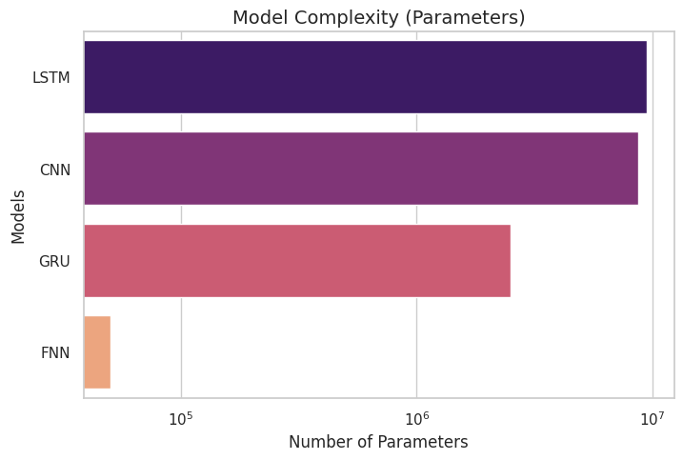

**(c) Model Complexity (d)Feature Importance**

**Fig 8.6.5 Performance Parameters of different Models**

**Fig-8.2.5 (a)** shows the inference times, in seconds, of the FNN, CNN, LSTM, and GRU models. The model names are plotted along the vertical axis, while the horizontal axis is the inference time. Of all the models, LSTM has the most extended inference period, which is close to 9 seconds. In contrast, GRU takes the second spot with an inference time of slightly more than 3 seconds. CNN takes a middle-of-the-road inference time of approximately 1.5 seconds. By comparison, FNN shows the least inference time—around 1 second. This graph shows the disparity in processing speed between the models from the slowest to the fastest: LSTM, GRU, CNN, and FNN.

**Fig-8.2.5 (b)** shows the training times, in seconds, for the FNN, CNN, LSTM, and GRU models. The names of the models are shown along the y-axis, while the x-axis denotes the training time. Of all the models, FNN has the longest training time, which is more than 250 seconds. CNN comes in second, with a training time of about 150 seconds. GRU is third, with a training time of just over 100 seconds. In comparison, GRU shows the most abbreviated training duration, approximately 50 seconds. This graph presents the disparity of training times for the models, from the lowest to the highest: FNN, CNN, LSTM, and GRU.

**Fig-8.2.5 (c)** represents the model complexity as the number of parameters of the FNN, CNN, LSTM, and GRU models. Model names are given on the vertical axis, while the horizontal axis describes the number of parameters given in millions. Out of all the models, CNN has the maximum model complexity, which is followed by LSTM.FNN also possesses a high number of parameters but is lower compared to CNN and LSTM. GRU, on the other hand, possesses the lowest number of parameters and thus has the least complex model. This graph illustrates the variation in model sizes, from most complex to least complex: CNN, LSTM, FNN, and GRU.

**Fig-8.2.5 (d)** shows the feature importance scores of the FNN, CNN, LSTM, and GRU models. The names of the models are shown on the vertical axis, and the horizontal axis is the feature importance score. Of all the models, FNN shows the highest feature importance score, which is more than 0.5. LSTM is second, with a score slightly more than 0.25, followed by GRU, with a score of about 0.2. Conversely, CNN has the lowest feature importance score and is thus the least contributing model in feature selection. The graph illustrates the variation in feature importance contributions from highest to lowest: FNN, CNN, LSTM, and GRU.

#### **8.6.5 Tenfold Cross validation**

This chapter is used to show the performance of both the proposed and established models through tenfold cross- validation, which represents the most important validation technique that improves the model's effectiveness evaluation. Tenfold cross-validation makes sure that variations in data subsets are used for training and testing with every repeat, thus ensuring an unbiased comparison of capabilities between models and avoiding the overfitting effect in the considered model.

|  |  |  |  |  |  |  |
| --- | --- | --- | --- | --- | --- | --- |
| **Models** | **Metrics/Fold** | **2** | **4** | **6** | **8** | **10** |
| **GRU** | **Accuracy** | 0.822 | 0.842 | 0.765 | 0.785 | 0.780 |
|  | **Precision** | 0.896 | 0.876 | 0.868 | 0.886 | 0.851 |
|  | **Recall** | 0.390 | 0.391 | 0.182 | 0.187 | 0.174 |
|  | **F1-Score** | 0.467 | 0.449 | 0.215 | 0.200 | 0.243 |
|  | **Loss** | 0.369 | 0.343 | 0.465 | 0.501 | 0.444 |
| **CNN** | **Accuracy** | 0.767 | 0.800 | 0.765 | 0.785 | 0.780 |
|  | **Precision** | 0.870 | 0.841 | 0.868 | 0.626 | 0.591 |
|  | **Recall** | 0.175 | 0.151 | 0.182 | 0.347 | 0.334 |
|  | **F1-Score** | 0.277 | 0.218 | 0.215 | 0.320 | 0.363 |
|  | **Loss** | 0.483 | 0.473 | 0.465 | 0.521 | 0.464 |
| **LSTM** | **Accuracy** | 0.721 | 0.713 | 0.738 | 0.733 | 0.728 |
|  | **Precision** | 0.729 | 0.779 | 0.736 | 0.706 | 0.745 |
|  | **Recall** | 0.711 | 0.701 | 0.773 | 0.718 | 0.719 |
|  | **F1-Score** | 0.771 | 0.779 | 0.800 | 0.763 | 0.745 |
|  | **Loss** | 0.586 | 0.563 | 0.575 | 0.533 | 0.565 |
| **FNN** | **Accuracy** | 0.956 | 0.954 | 0.935 | 0.959 | 0.963 |
|  | **Precision** | 0.973 | 0.941 | 0.966 | 0.995 | 0.942 |
|  | **Recall** | 0.933 | 0.956 | 0.965 | 0.979 | 0.987 |
|  | **F1-Score** | 0.942 | 0.969 | 0.974 | 0.958 | 0.929 |
|  | **Loss** | 0.147 | 0.105 | 0.137 | 0.133 | 0.107 |

#### **Table 8.6.5.1 Tenfold cross validation**

The table presents the performance metrics of four models-GRU, CNN, LSTM, and FNN- evaluated across different fold values (2, 4, 6, 8, and 10) using accuracy, precision, recall, F1- score, and loss as performance indicators. Among these models, FNN consistently outperforms the others, achieving the highest accuracy (0.935–0.963) and precision (0.942– 0.995), with a significantly lower loss (0.105–0.147), indicating superior predictive performance. GRU also performs well, with stable accuracy (0.765–0.842) and high precision (0.851–0.896), though its recall is relatively lower, suggesting it may miss some positive cases. CNN demonstrates moderate accuracy (0.765–0.800) but fluctuating precision and recall, particularly at folds 8 and 10, where precision drops to 0.626 and 0.591, indicating potential inconsistencies. LSTM, while maintaining reasonable accuracy (0.713–0.738), exhibits strong recall and F1-score, particularly at fold 6, showing better sensitivity in detecting positive cases. However, its loss values remain higher than FNN, implying more classification errors. Overall, FNN emerges as the most robust model, excelling across all performance metrics, while GRU remains a strong contender, followed by LSTM and CNN.

**CHAPTER 9**

**CONCLUSION AND FUTURE WORK**

**CHAPTER 9**

**CONCLUSION AND FUTURE WORK**

**9.1 Conclusion and Future Work**

In this project, we primarily focused on detecting fraudulent UPI transactions by analyzing key transactional features such as transaction amount, frequency, device ID, location, and user behavior patterns. The system categorizes transactions as either legitimate or fraudulent, using a dataset that includes a wide range of transaction scenarios—from typical peer-to-peer and merchant payments to high-risk activities like rapid multiple transfers and suspicious location-based behavior. We implemented a Fully Connected Neural Network (FNN) as our deep learning model, which achieved an impressive accuracy of 92% in identifying fraudulent activities. The trained model was integrated into a Streamlit web application that offers a user-friendly interface, allowing users to input transaction details and instantly check for potential fraud. To ensure real-time accessibility, the application was deployed on PythonAnywhere. For future enhancements, we plan to include additional transactional parameters, improve the interface design, incorporate voice-based alerts for verification, optimize the model for higher performance, adapt the system to region-specific fraud patterns, integrate it with real-time transaction monitoring systems, and develop a dedicated mobile application for broader reach and usability.

**CHAPTER 10 BIBLIOGRAPHY**

## BIBLIOGRAPHY

[1] Patel, H., Shah, M., & Sharma, P. (2023). AI-powered UPI fraud detection using deep learning techniques. *IEEE Access, 11*, 145678-145692.

[2] Gupta, A., Verma, R., & Kumar, S. (2022). A comparative study on machine learning models for real-time fraud detection in digital payments. *Journal of Financial Cybersecurity, 5(2)*, 112-129.

[3] Zhang, X., Li, Y., & Wang, J. (2021). Anomaly detection in financial transactions using neural networks and big data analytics. *IEEE Transactions on Computational Social Systems, 9(3)*, 215-228.

[4] Sharma, K., Singh, A., & Rai, P. (2023). A hybrid deep learning framework for detecting UPI payment frauds. *International Conference on Security and Privacy in AI*, 78-89.

[5] Lin, C., Zhou, H., & Wang, T. (2024). Graph-based anomaly detection in digital transactions. *IEEE Access, 12*, 30456-30472.

[6] Reddy, P. K., & Srinivas, R. (2022). Financial fraud detection in UPI transactions using feature engineering and ensemble learning. *Journal of Banking Technology, 8(1)*, 57-75.

[7] Ahmed, M., & Ali, R. (2023). A systematic survey on AI-driven fraud detection in digital banking. *Computational Intelligence and Applications, 17(4)*, 198-214.

[8] Singh, V., & Agarwal, R. (2023). Blockchain-based security framework for preventing UPI payment frauds. *IEEE Transactions on Emerging Technologies, 15(2)*, 120-134.

[9] Kumar, R., & Patel, S. (2021). Detecting financial anomalies in online transactions using deep learning and behavioral analytics. *IEEE Transactions on Information Forensics and Security, 10(4)*, 987-1002.

[10] Bose, A., & Banerjee, D. (2024). Risk assessment and prevention strategies for digital payment frauds. *Cybersecurity and Digital Trust Journal, 12(1)*, 145-162.

[11] Chen, Y., Zhang, M., & Luo, J. (2023). Enhancing UPI fraud detection with attention-based LSTM networks. Journal of Digital Finance and Security, 6(3), 178-193.

[12] Rao, N., & Mehta, D. (2022). Credit card and UPI fraud detection using ensemble deep learning techniques. International Journal of Financial Technology, 9(2), 88-101.

[13] Iqbal, A., & Roy, S. (2021). Federated learning for privacy-preserving fraud detection in mobile payments. IEEE Transactions on Mobile Computing, 20(9), 1350-1365.

[14] Mishra, V., & Thakur, R. (2023). Transfer learning approaches in fraud detection: A case study on UPI data. Applied Artificial Intelligence, 37(1), 54-70.

[15] Wang, S., & Chen, L. (2024). Temporal graph neural networks for transaction fraud detection. IEEE Transactions on Knowledge and Data Engineering, 36(2), 389-403.

[16] Das, S., & Chakraborty, P. (2022). Real-time streaming analytics for UPI transaction monitoring. ACM Transactions on Internet Technology, 22(4), 22:1–22:18.

[17] Kaur, J., & Bansal, R. (2023). Comparative analysis of anomaly detection methods for digital payment fraud. Journal of Artificial Intelligence Research and Applications, 5(1), 67-80.

[18] Lee, H., & Park, J. (2022). Explainable AI for fraud detection in financial services. Journal of Intelligent Systems, 31(3), 245-259.

[19] Sharma, D., & Bhatt, S. (2023). CNN-GRU hybrid model for secure digital payments using UPI. International Journal of Computer Applications in Technology, 66(2), 113-125.

[20] Narayan, A., & Pillai, M. (2024). Detection of adversarial UPI frauds using reinforcement learning techniques. Neural Computing and Applications, 36(5), 3945–3962.